Time Series Unit 1/HW 1 Solutions

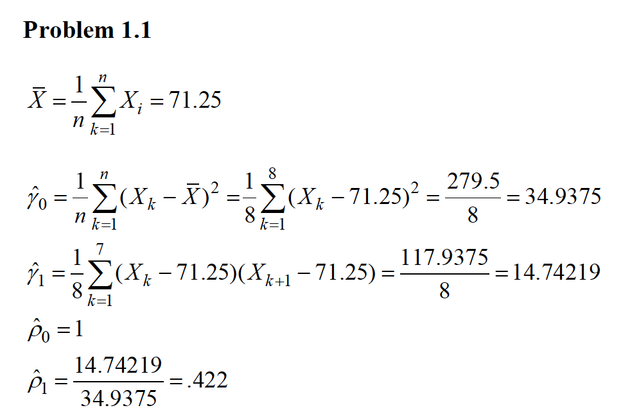

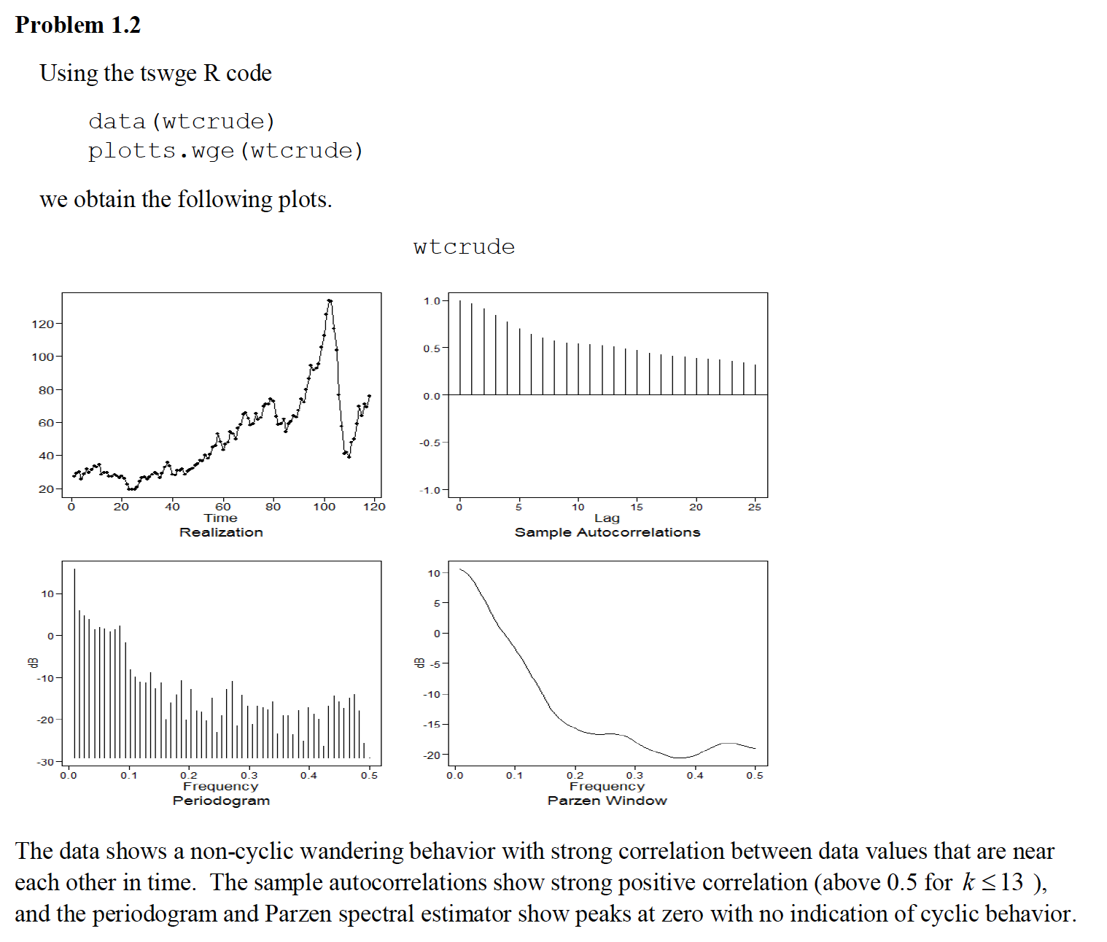

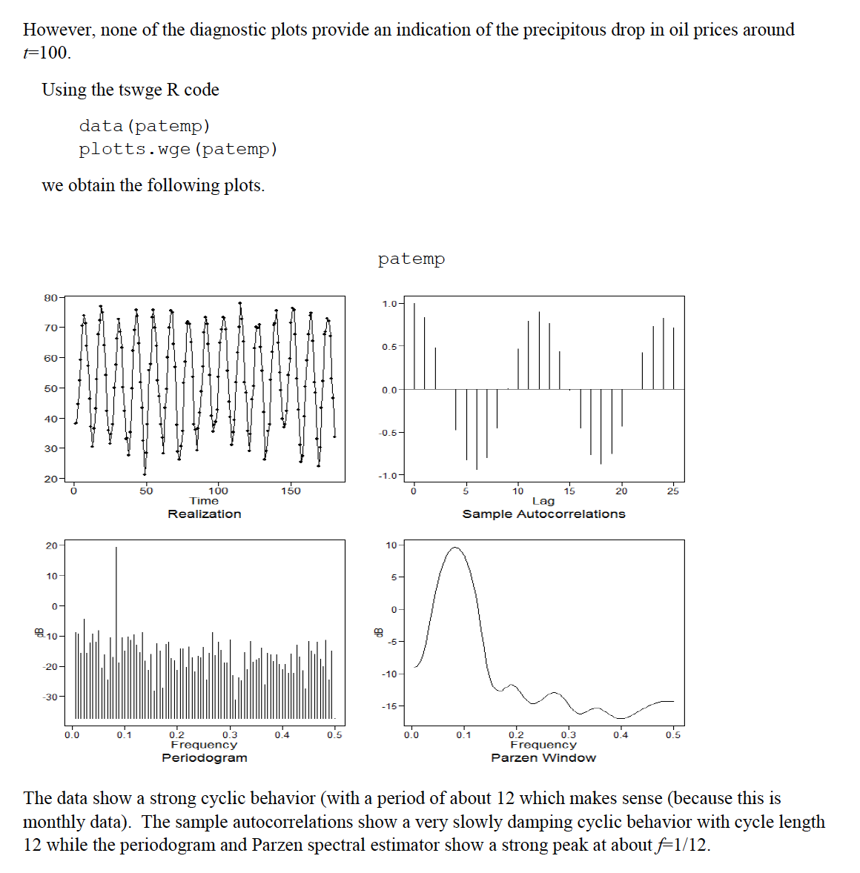

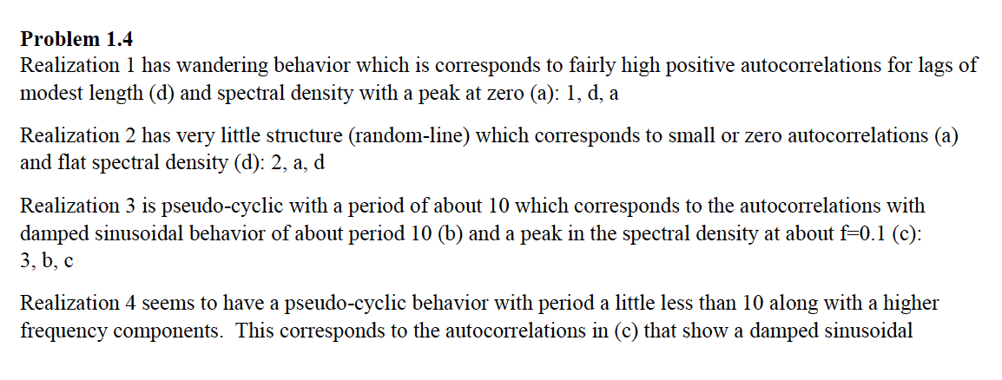



**Problem 1.5**

data("fig1.21a")

parzen.wge(fig1.21a,dbcalc = FALSE)

parzen.wge(fig1.21a,dbcalc = TRUE)

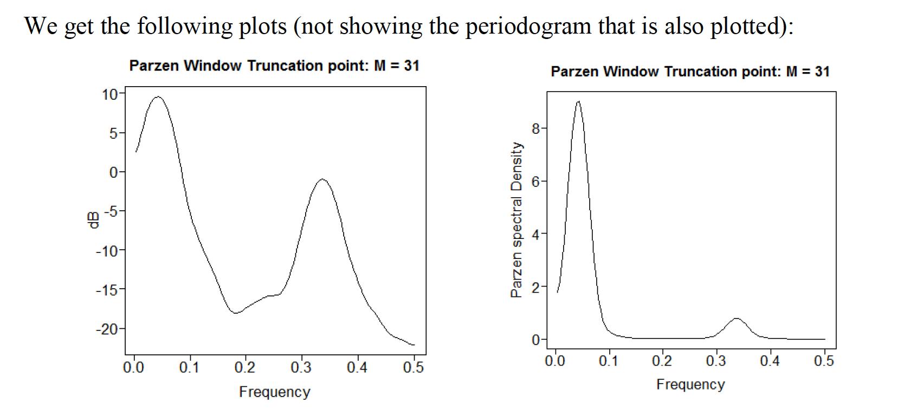

Both show strong indication of a peak at abouit *f*=0.05. However, the plot in dB shows the secondary peak at about *f*=0.33 much more clearly.

**Problem 1.6**

For UNIT 1 … only a – c are assigned. (d will be in Unit 2).

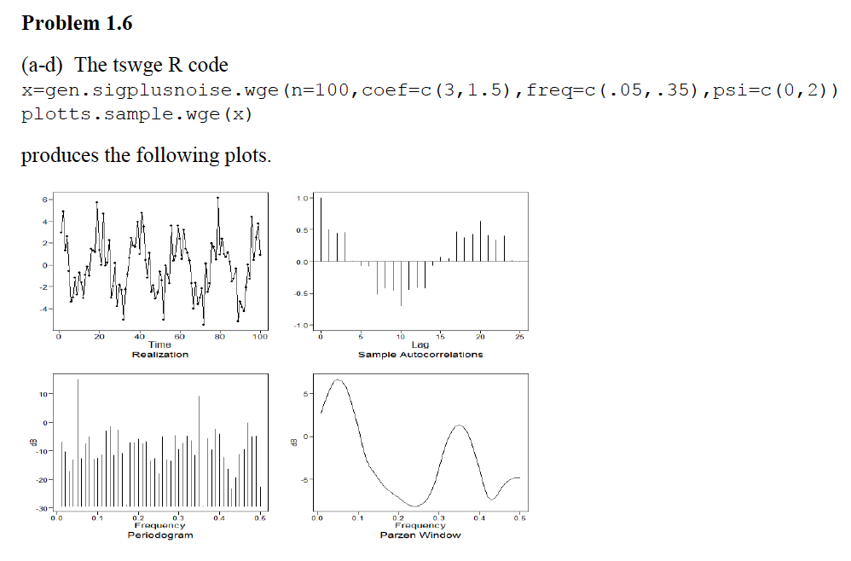

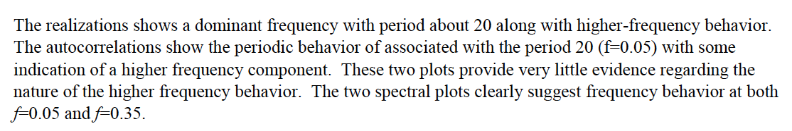

DS 6373: Time Series: Unit 2 HW Solutions

Below are the homework (HW) problems for this Unit. You do not need to submit the solutions rather double check your solutions to the solutions posted. Solutions will be posted to the Wall a few days after the release of the HW. This is intended to let the student think about the problem and attempt it without the temptation to first look at the solution. Please write any questions to the Wall or in an email to myself and/or bring them up during office hours or even in the next Live Session. Remember that the concepts covered below are fundamental to the course and are fair game for the midterm and final.

Have a blast!

Problems from the Textbook:

1.5

1.6 d

Solutions:

1.5

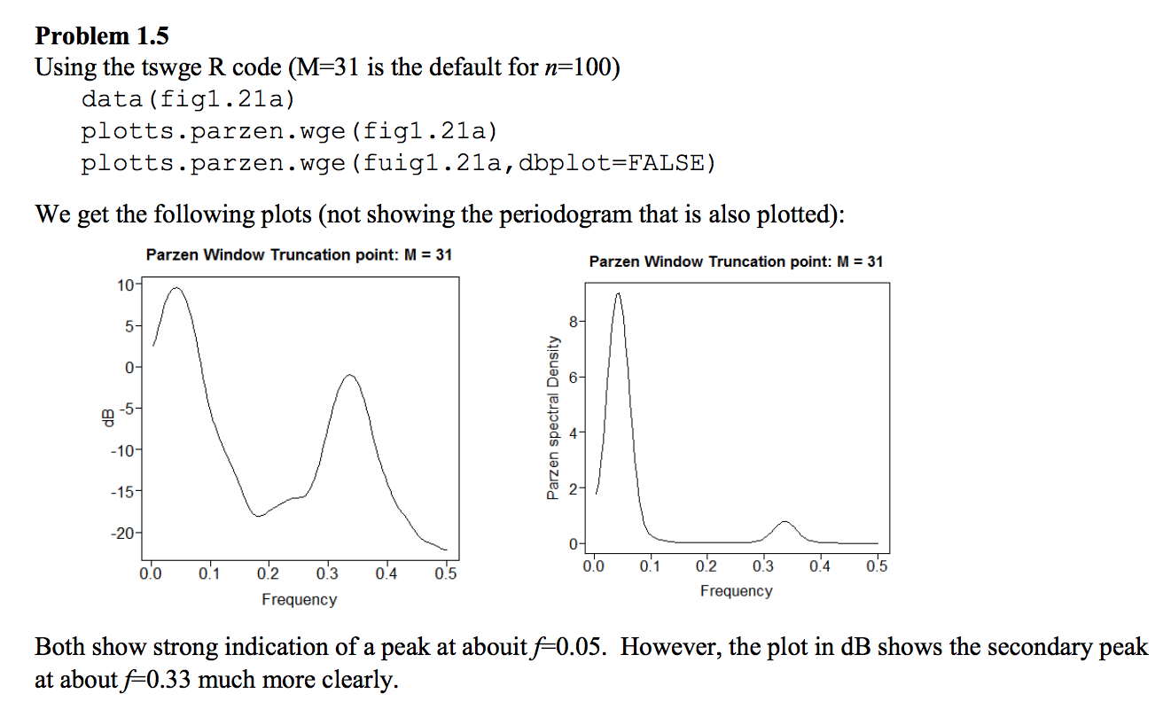

1.6

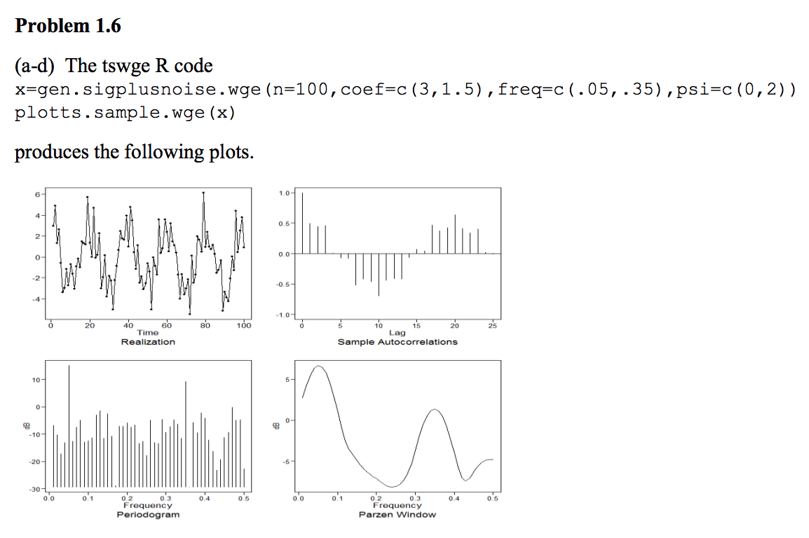

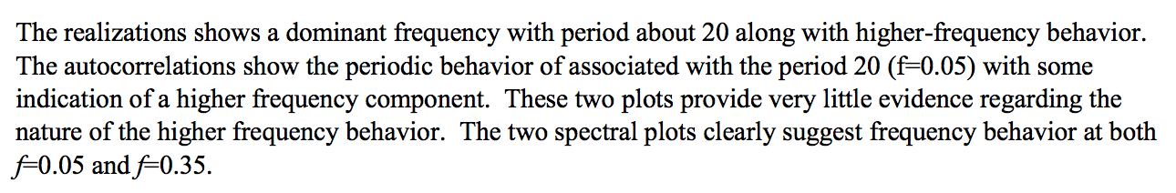

DS 6373: Time Series: Unit 3 HW Solutions

Below are the homework (HW) problems for this Unit. You do not need to submit the solutions rather double check your solutions to the solutions posted. Solutions will be posted to the Wall a few days after the release of the HW. This is intended to let the student think about the problem and attempt it without the temptation to first look at the solution. Please write any questions to the Wall or in an email to myself and/or bring them up during office hours or even in the next Live Session. Remember that the concepts covered below are fundamental to the course and are fair game for the midterm and final.

Have a blast!

Problems from Chapter 2 of the Textbook:

2.1

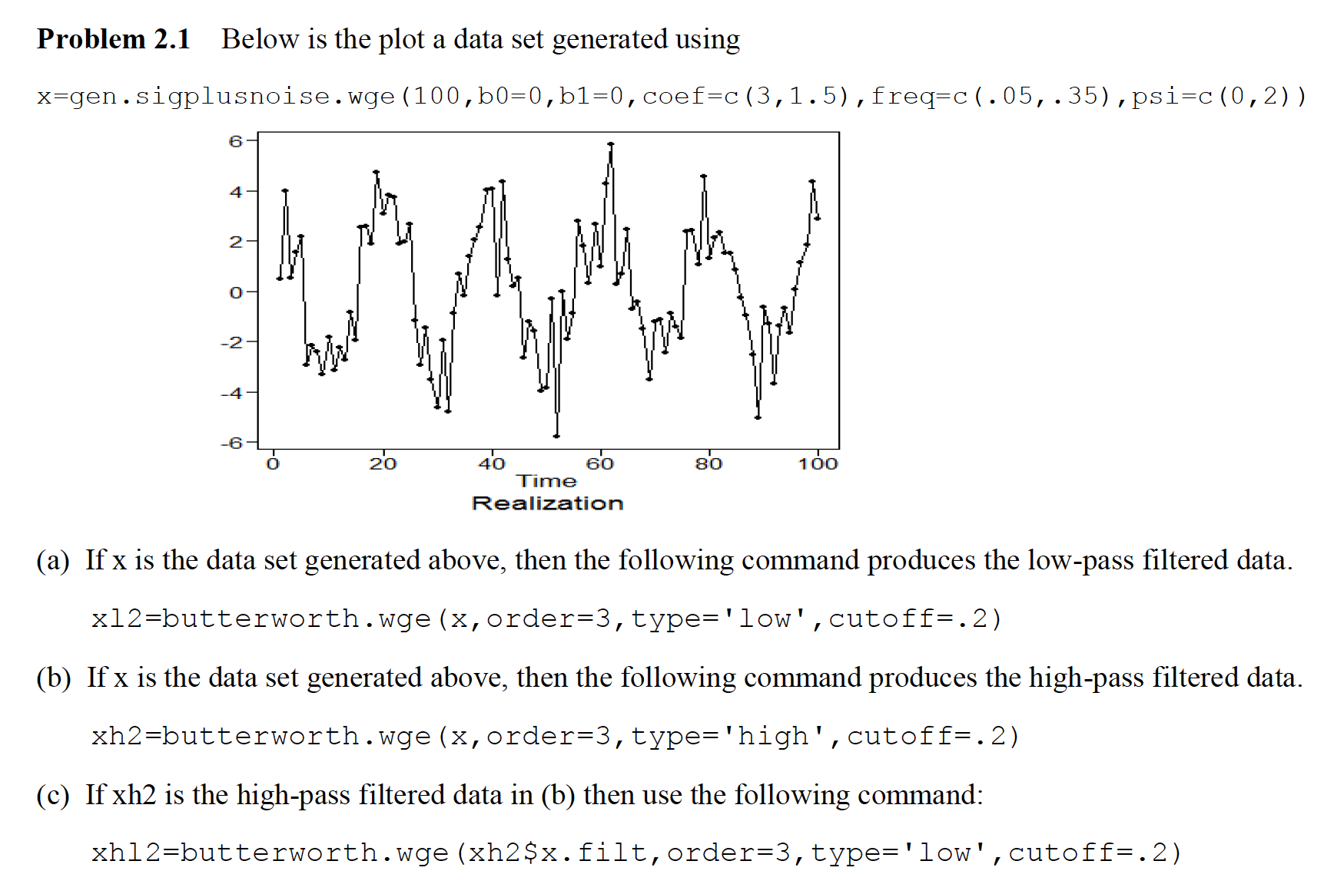

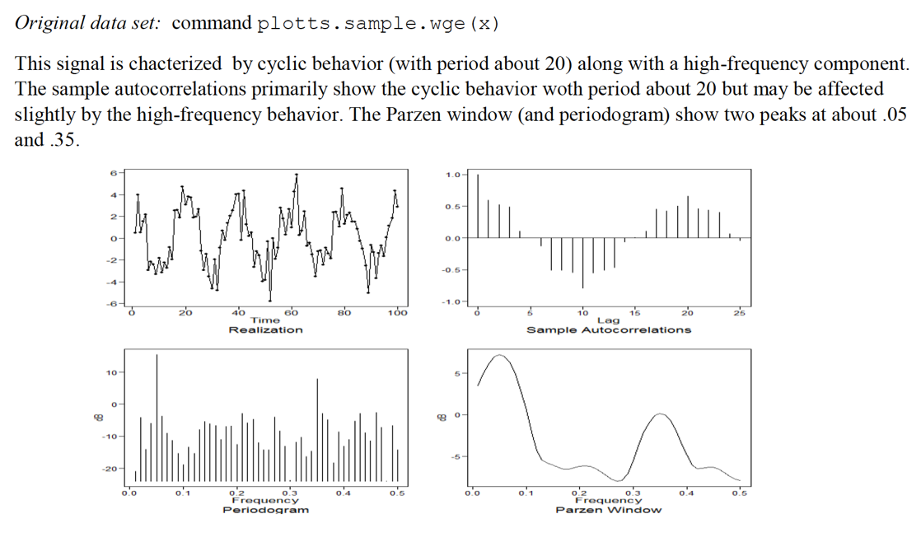

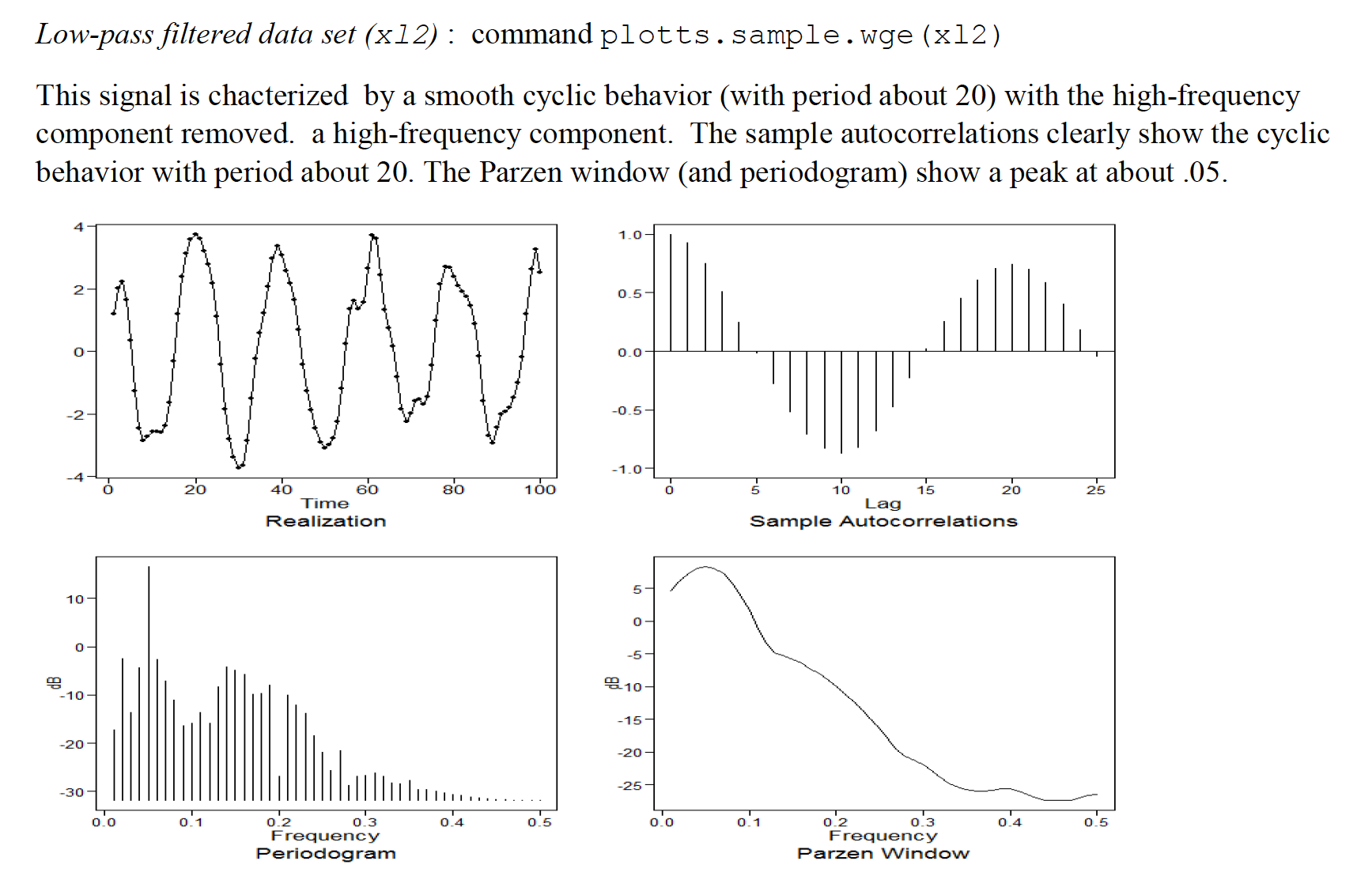  
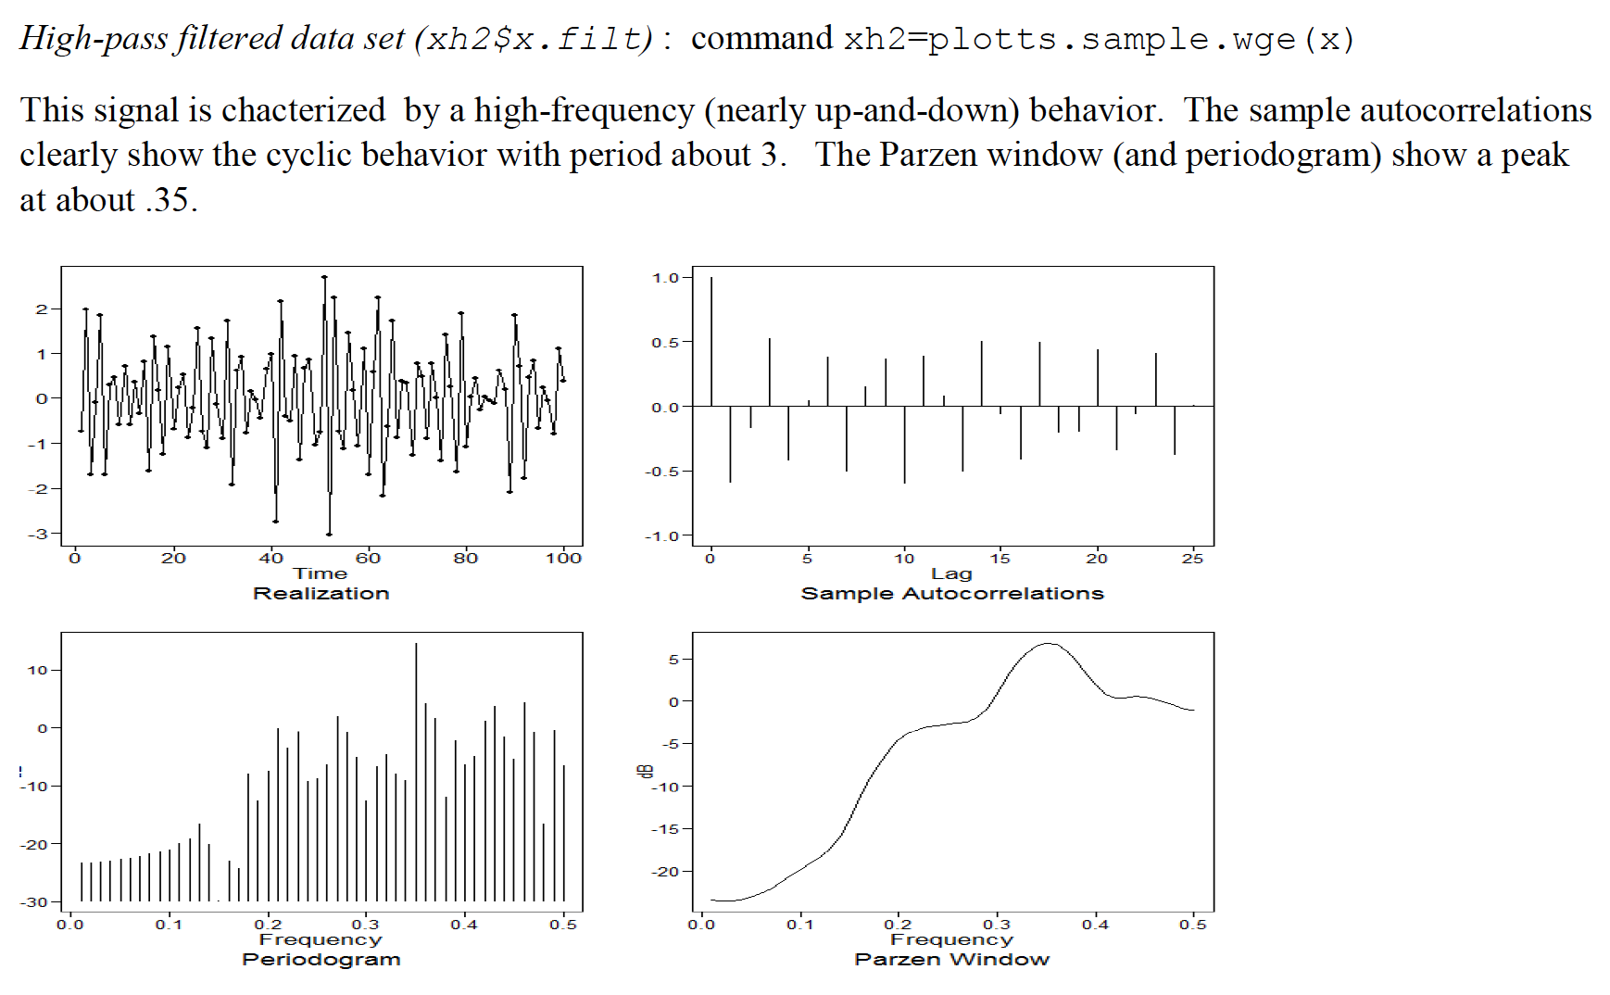

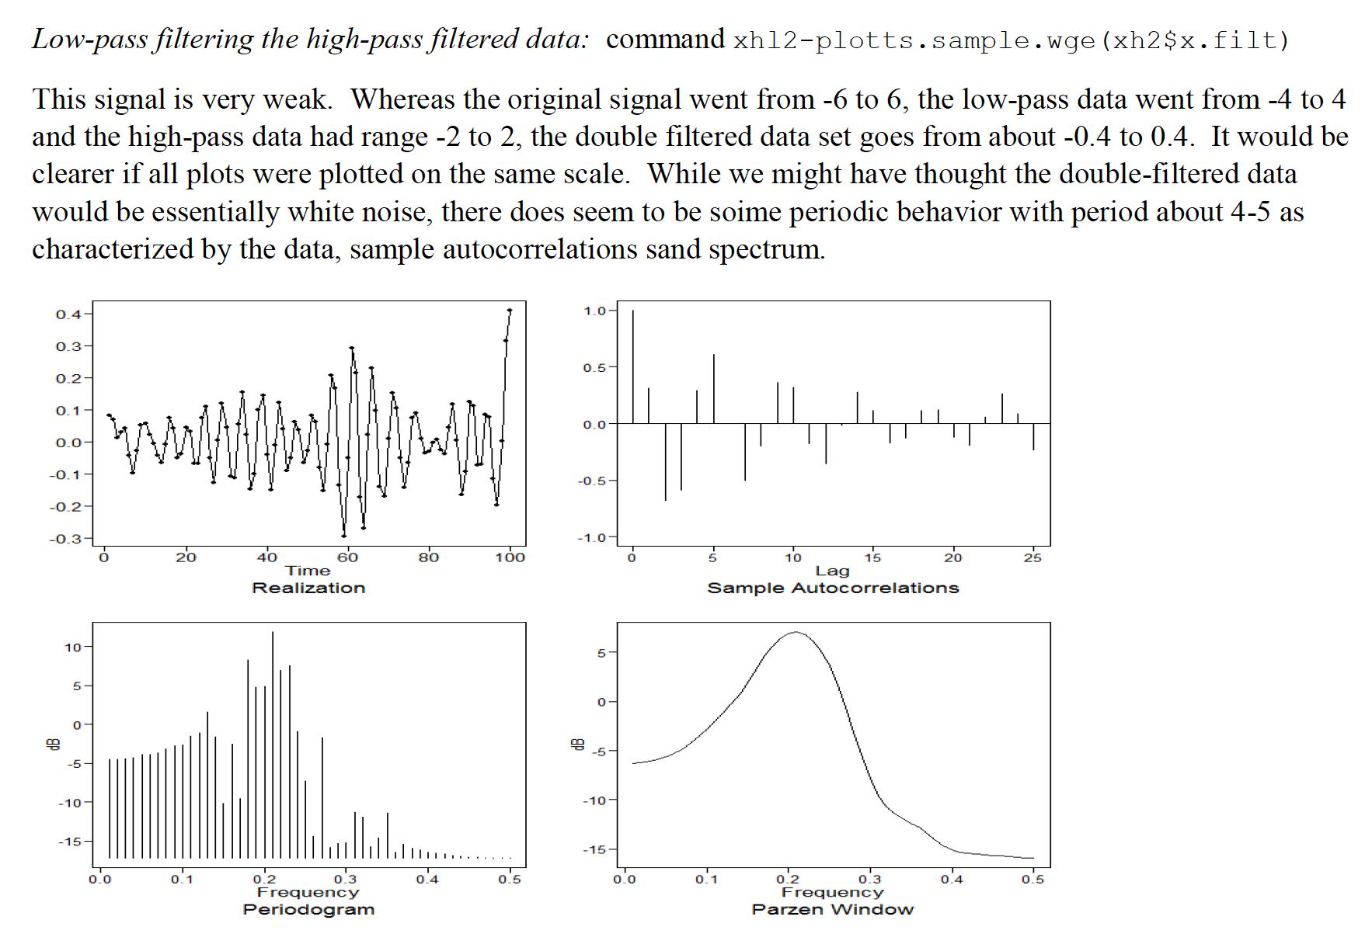

2.3

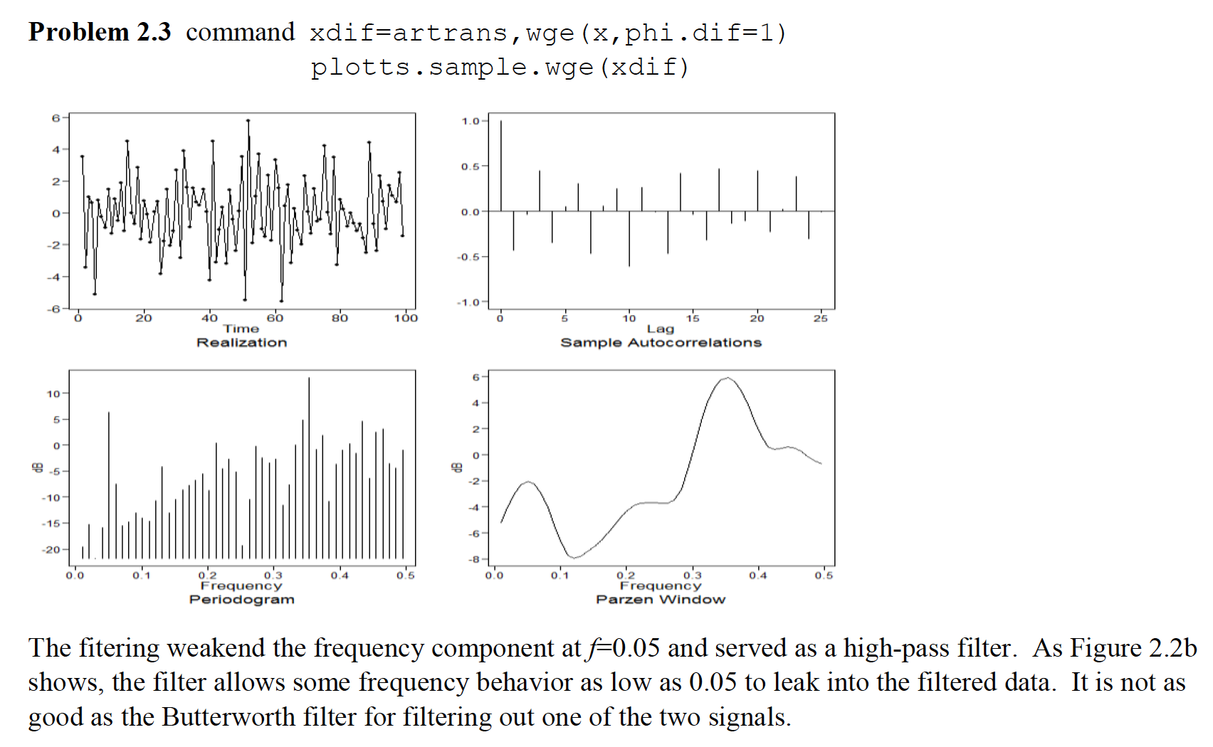

Additional Problem

Apply a 5-point moving average to the series you created in 2.1. How does it compare to the difference and Butterworth filters? Specifically, is it a low pass or high pass filter?

I was not able to reproduce the realization in 2.1 above since the seed (sn) was not specified. However, below is another realization produced from the same parameters.

x=gen.sigplusnoise.wge(100,b0=0,b1=0,coef=c(3,1.5),freq=c(.05,.35),psi=c(0,2), sn = 8)



ma = filter(x,rep(1/5,5))

plot(ma)



The 5 point moving average filter is a low pass filter the effects of which can be viewed above. While there is still possibly some remnants of the higher frequency, it the low frequency that dominates the filtered realization. It is most comparable to a Butterworth low pass filter with cutoff of .2 although this MA filter does not appear to filter out the higher frequency as well. This is partially because the order of the Butterworth filter was set to 3.

Problems from Chapter 3 of the Textbook:

3.4

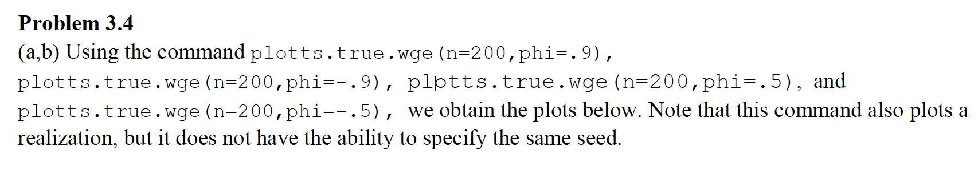

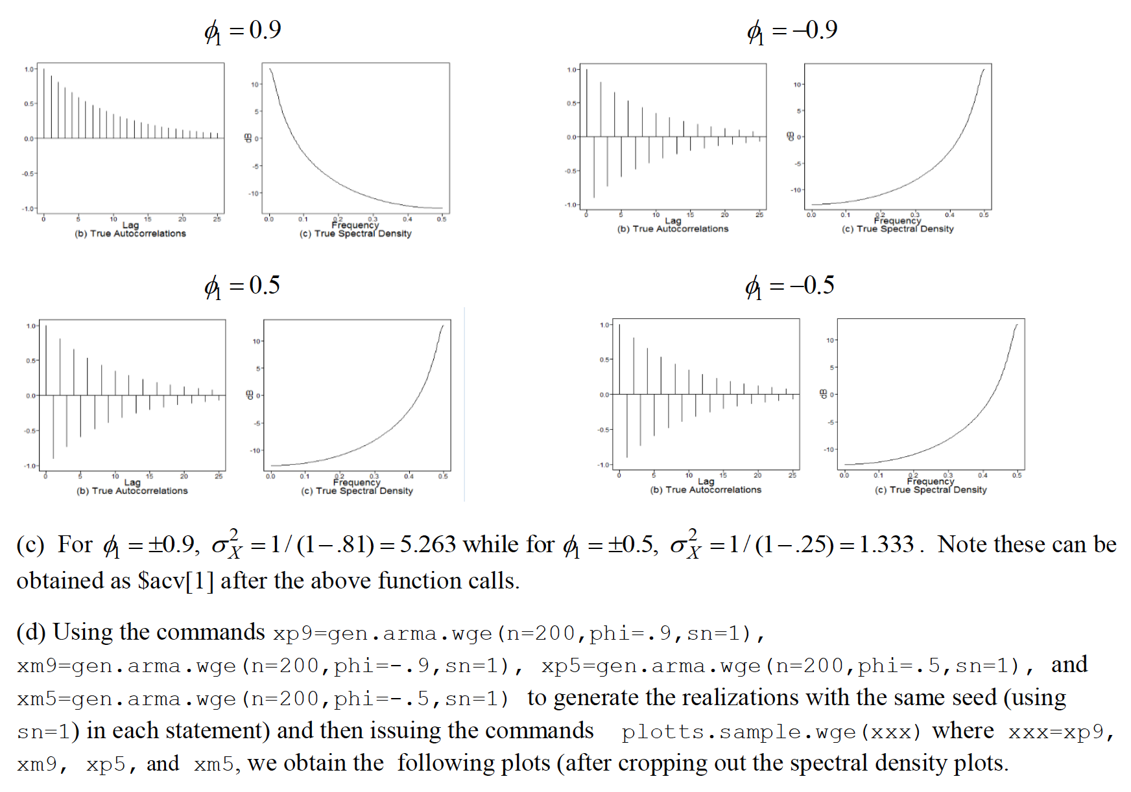

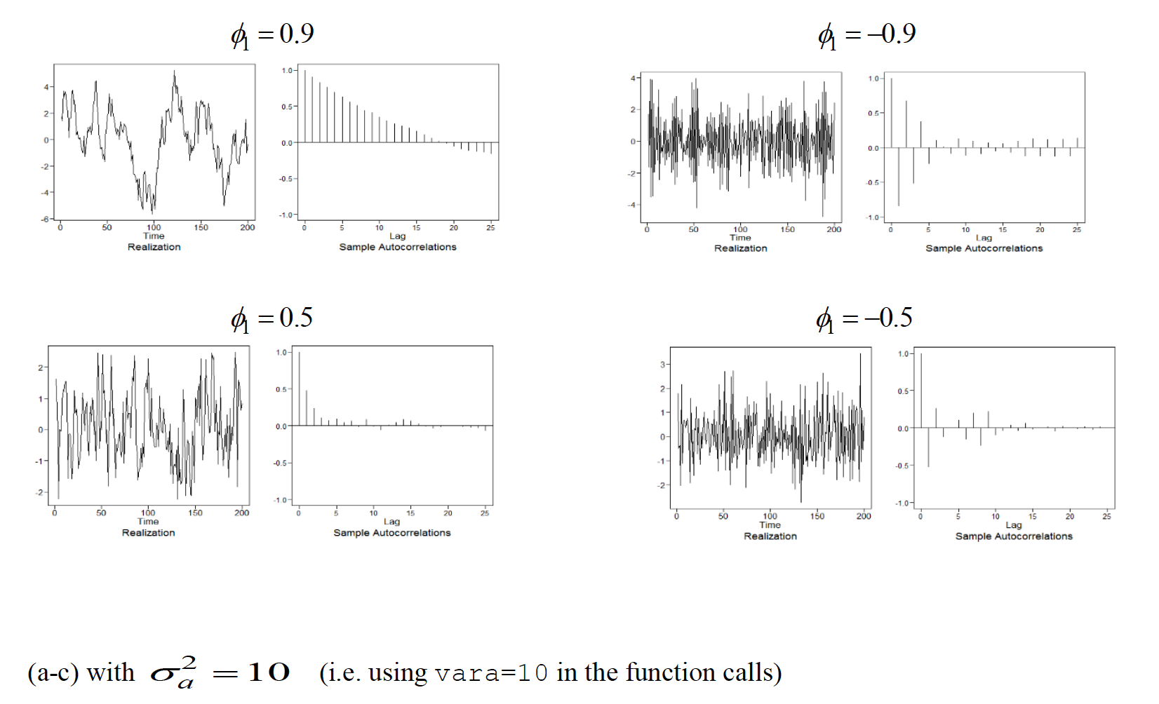

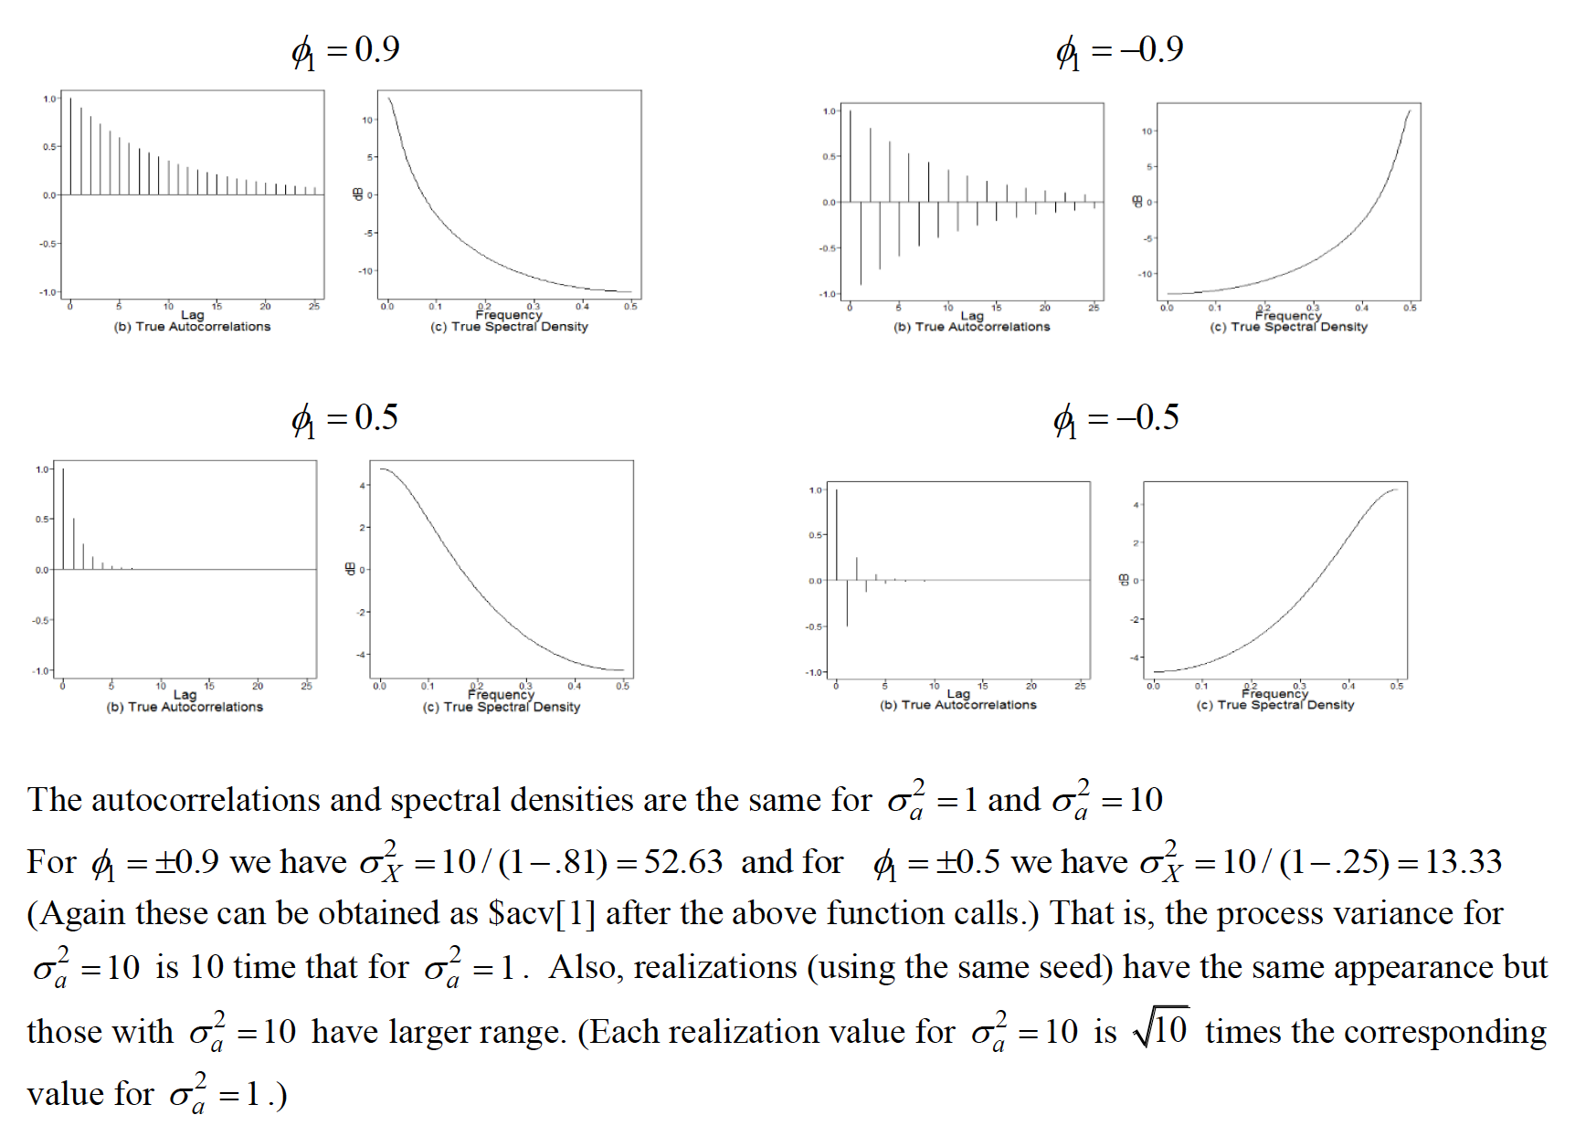

DS 6373: Time Series: Unit 4 HW Solution

Below are the homework (HW) problems for this Unit. You do not need to submit the solutions rather double check your solutions to the solutions posted. Solutions will be posted to the Wall a few days after the release of the HW. This is intended to let the student think about the problem and attempt it without the temptation to first look at the solution. Please write any questions to the Wall or in an email to myself and/or bring them up during office hours or even in the next Live Session. Remember that the concepts covered below are fundamental to the course and are fair game for the midterm and final.

Have a blast!

Problems from Chapter 3 of the Textbook:

3.2

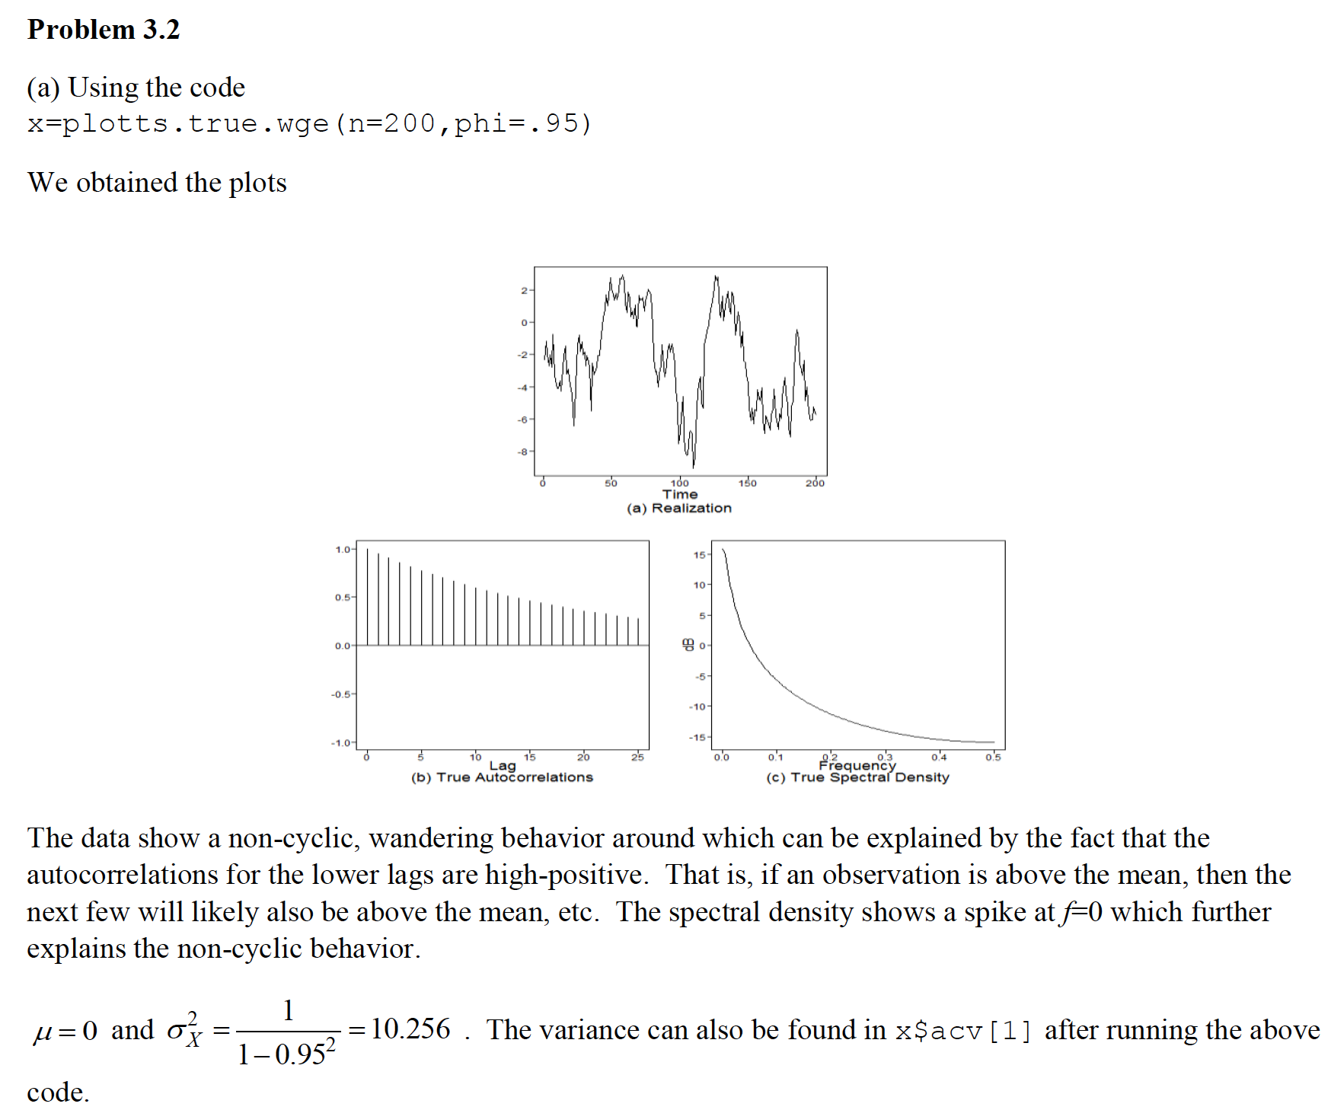

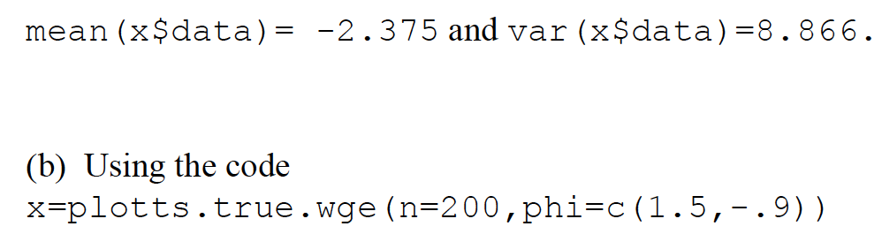

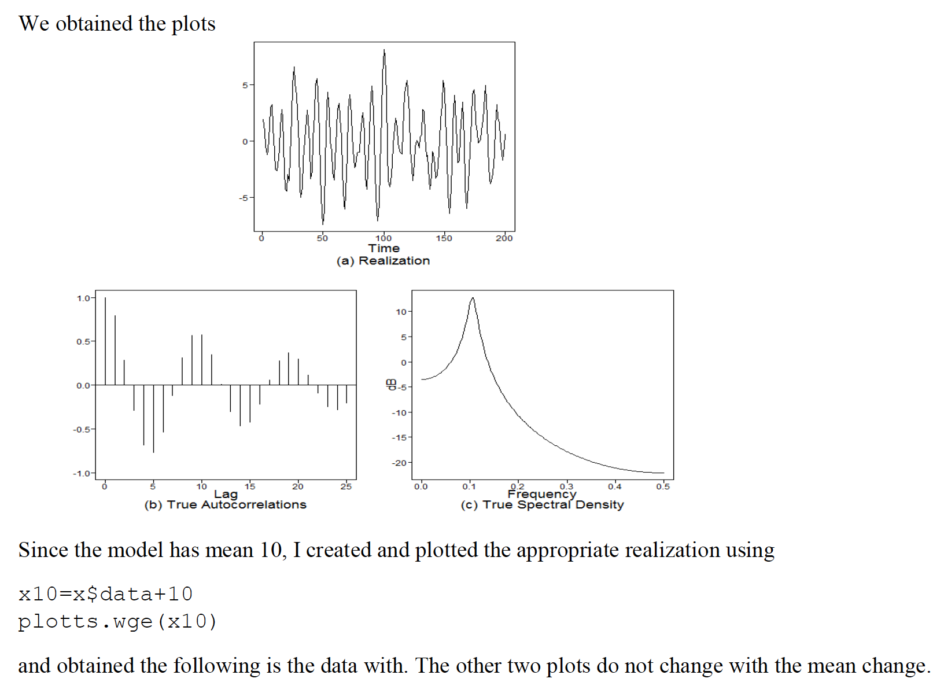

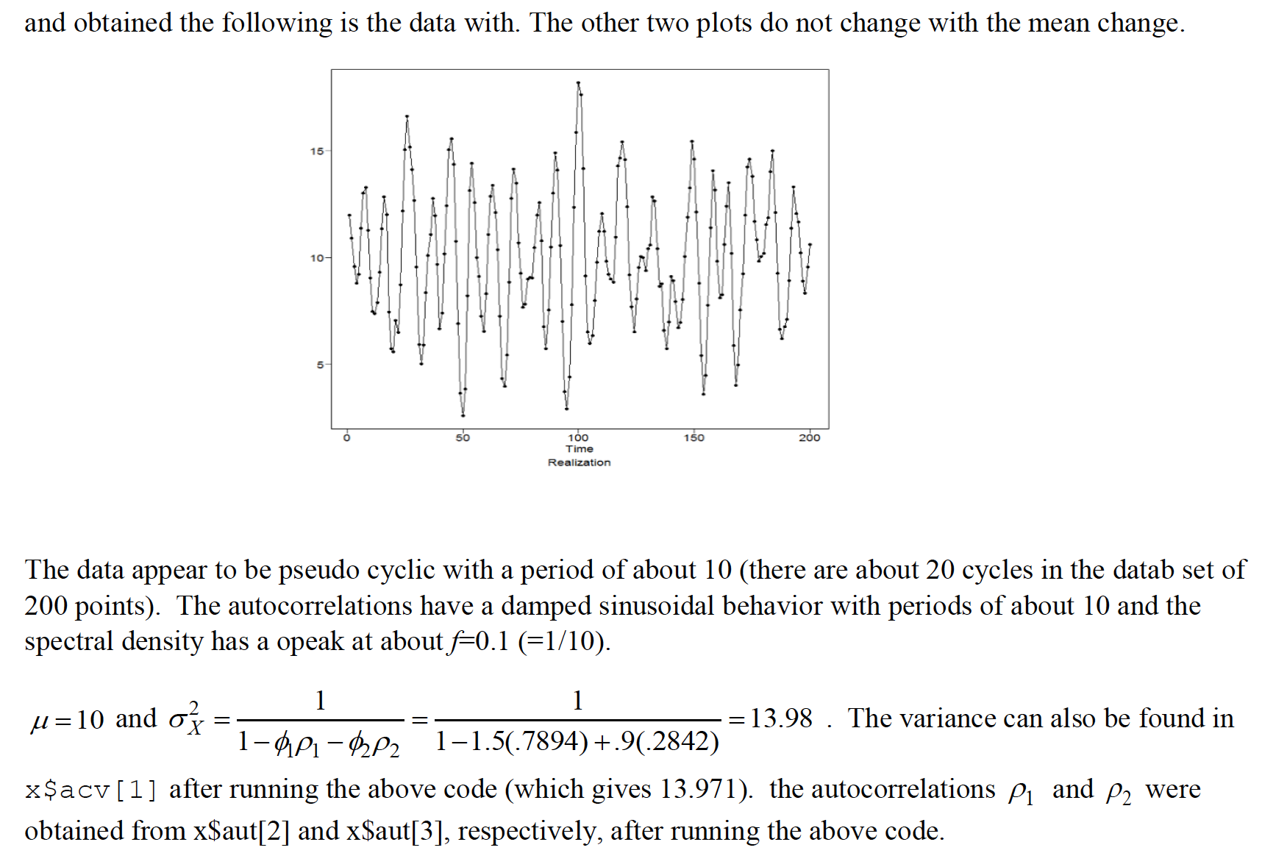



3.3 a,b, and d.

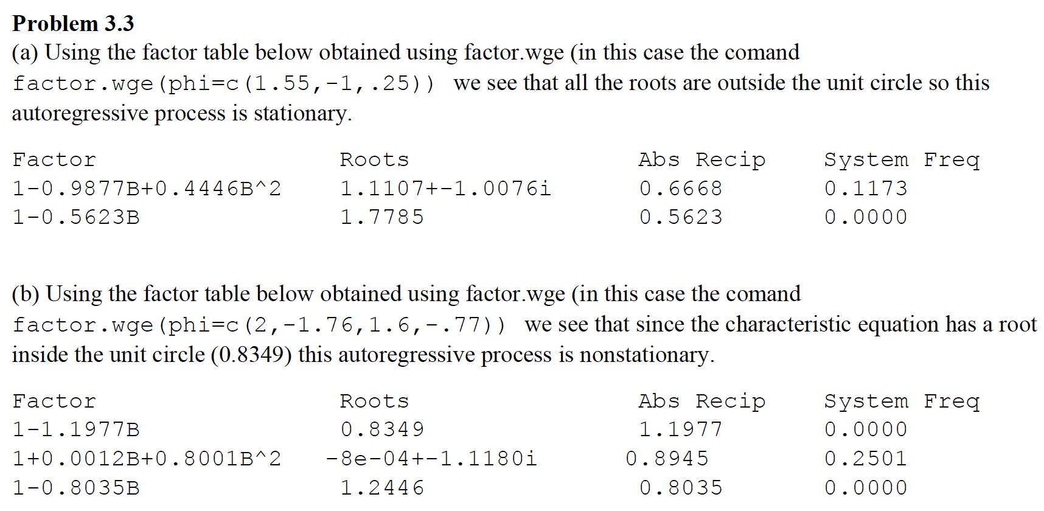

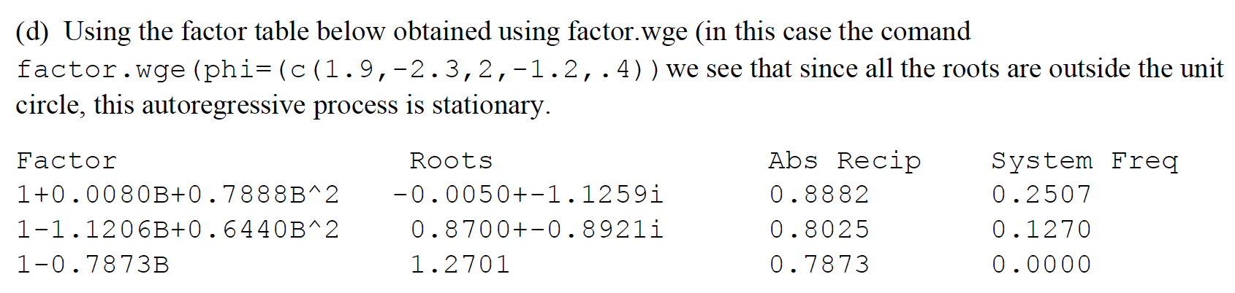

Additional Question, with respect to question 3.3. What is the obvious difference between (3.3a,b and d) and (3.3c)?

33.c is a function of the white noise rather than lagged observations of X.

DS 6373: Time Series: Unit 5 HW Solutions

Below are the homework (HW) problems for this Unit. You do not need to submit the solutions rather double check your solutions to the solutions posted. Solutions will be posted to the Wall a few days after the release of the HW. This is intended to let the student think about the problem and attempt it without the temptation to first look at the solution. Please write any questions to the Wall or in an email to myself and/or bring them up during office hours or even in the next Live Session. Remember that the concepts covered below are fundamental to the course and are fair game for the midterm and final.

Have a blast!

Problems from Chapter 3 of the Textbook:

3.1

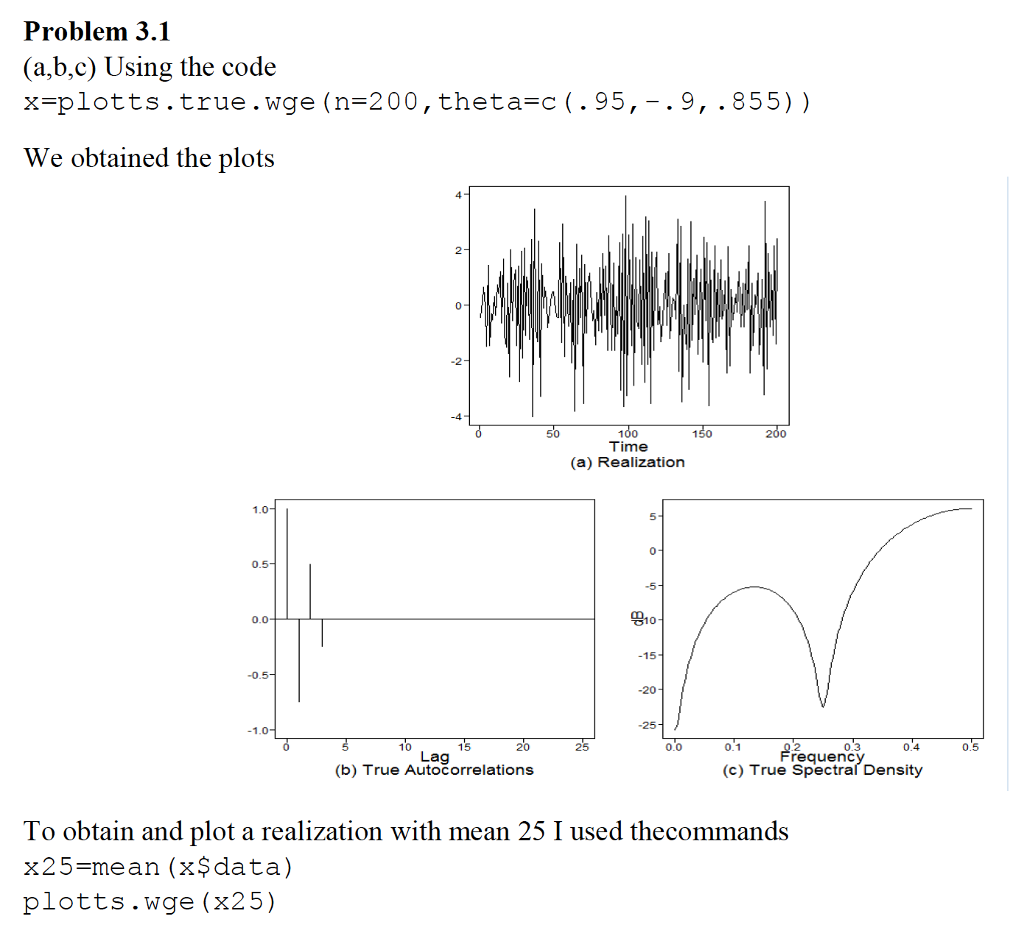

X25 = x$data + 25

plotts.wge(x25)

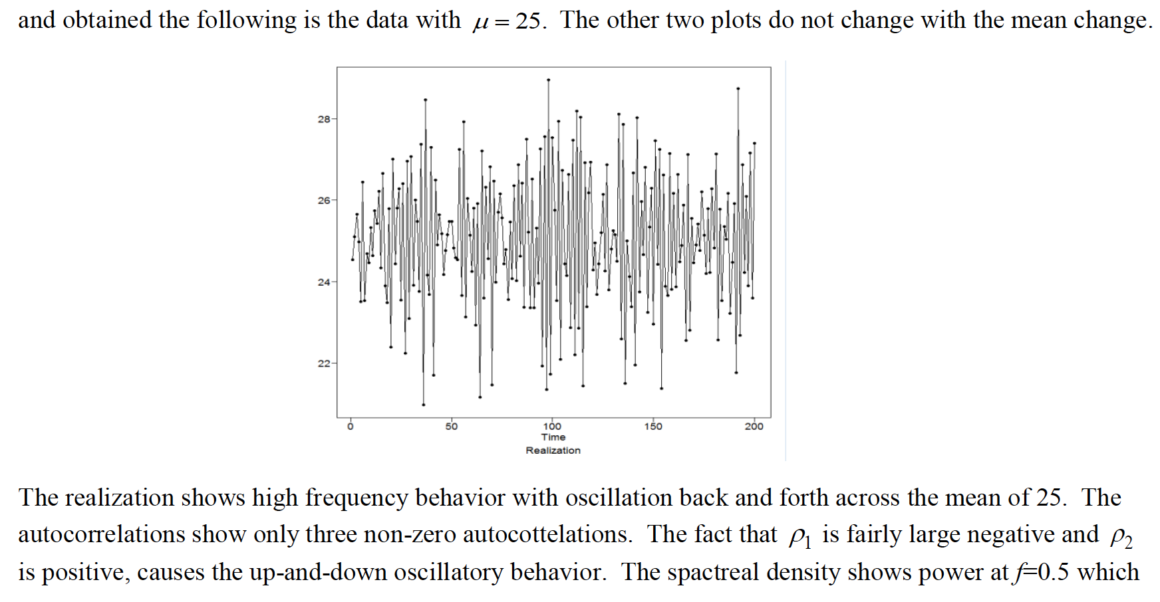

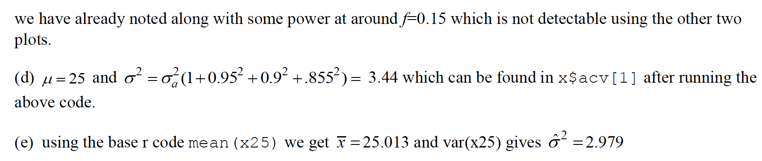

3.3 (c)

This is a moving average model which is always stationary since it is a linear combination of white noise terms which are individually stationary. All moving average models are stationary, they may not be invertible, but they are stationary.

3.6

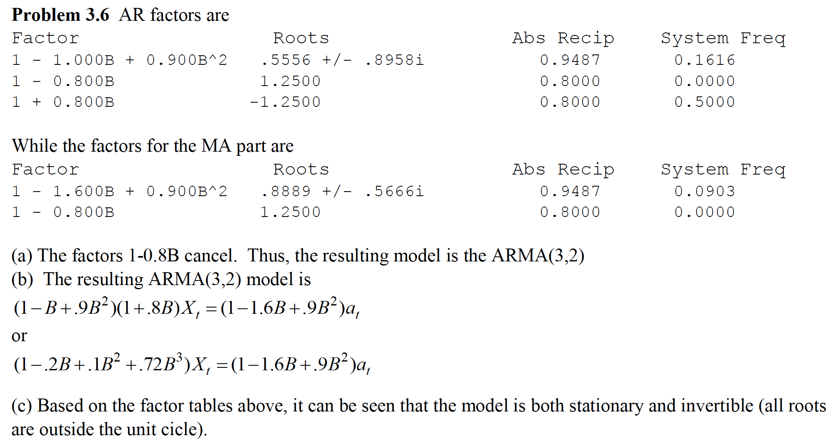

3.7

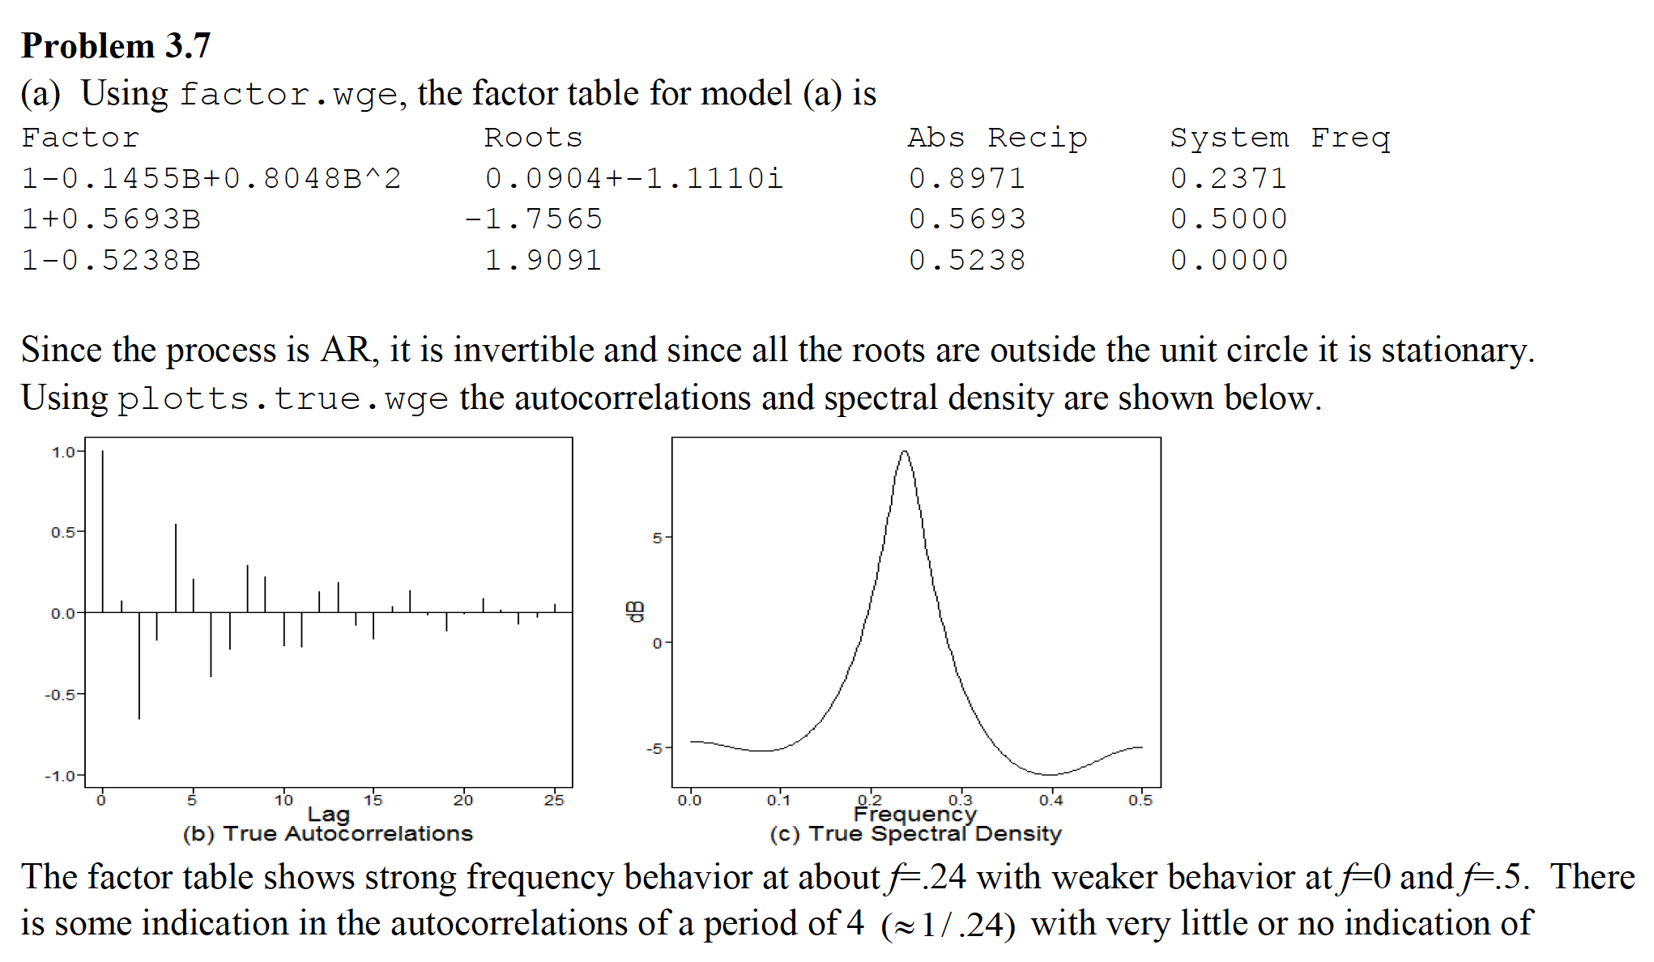

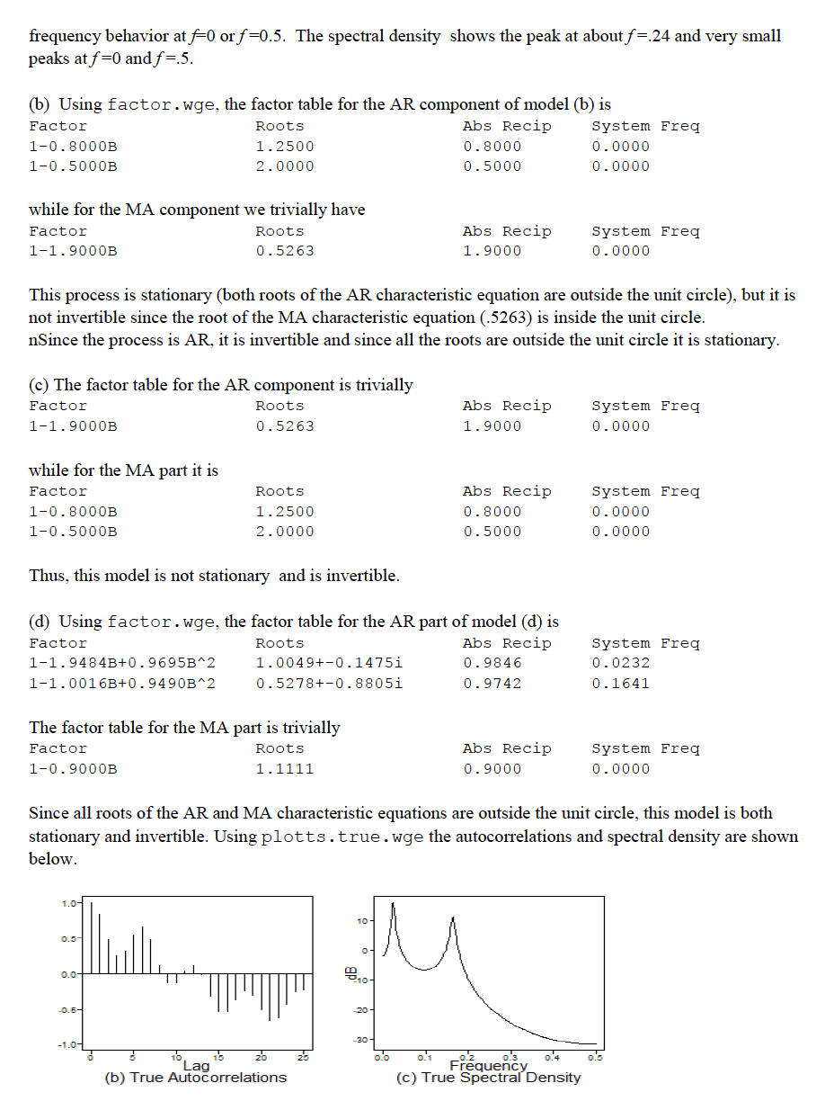

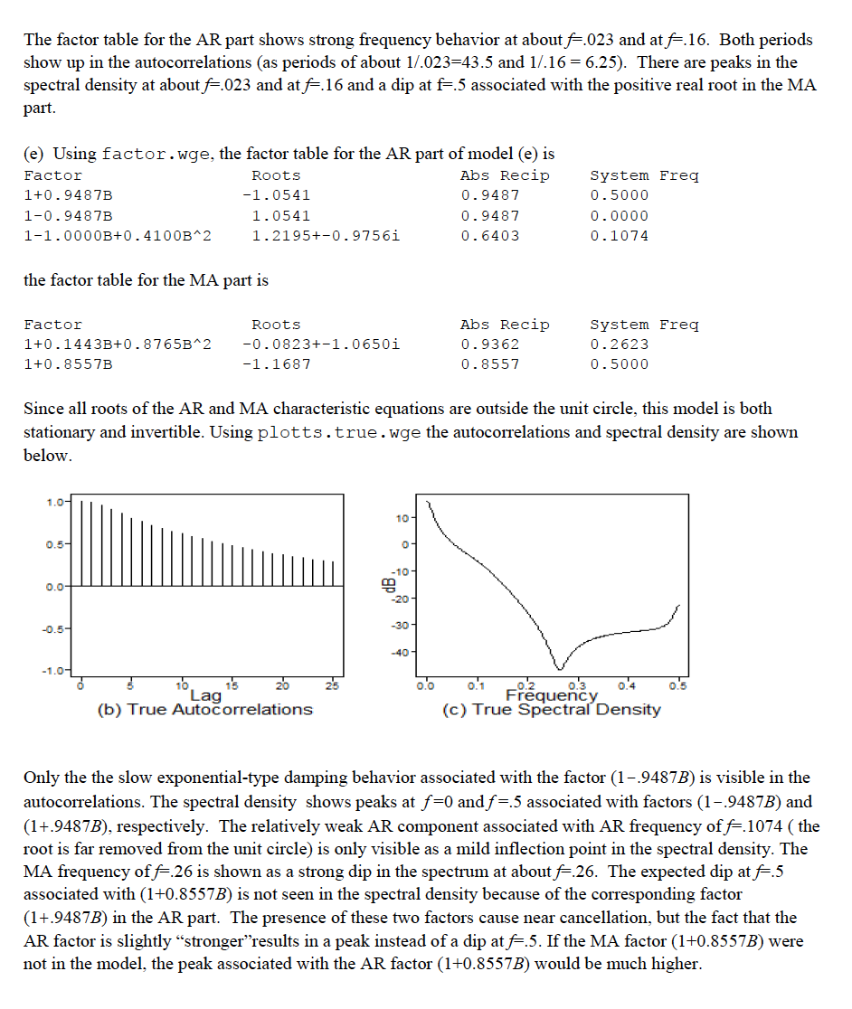

3.8

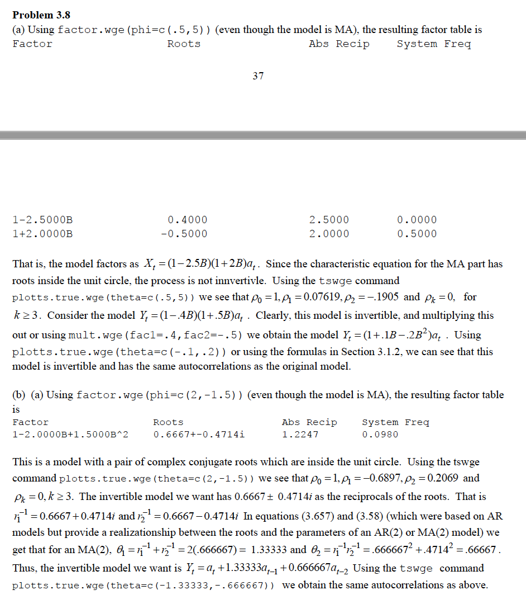



3.11

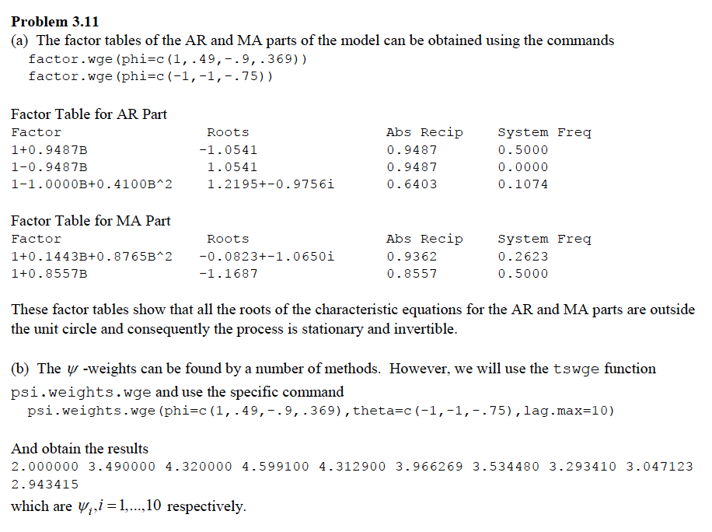

3.13: Just for (i)

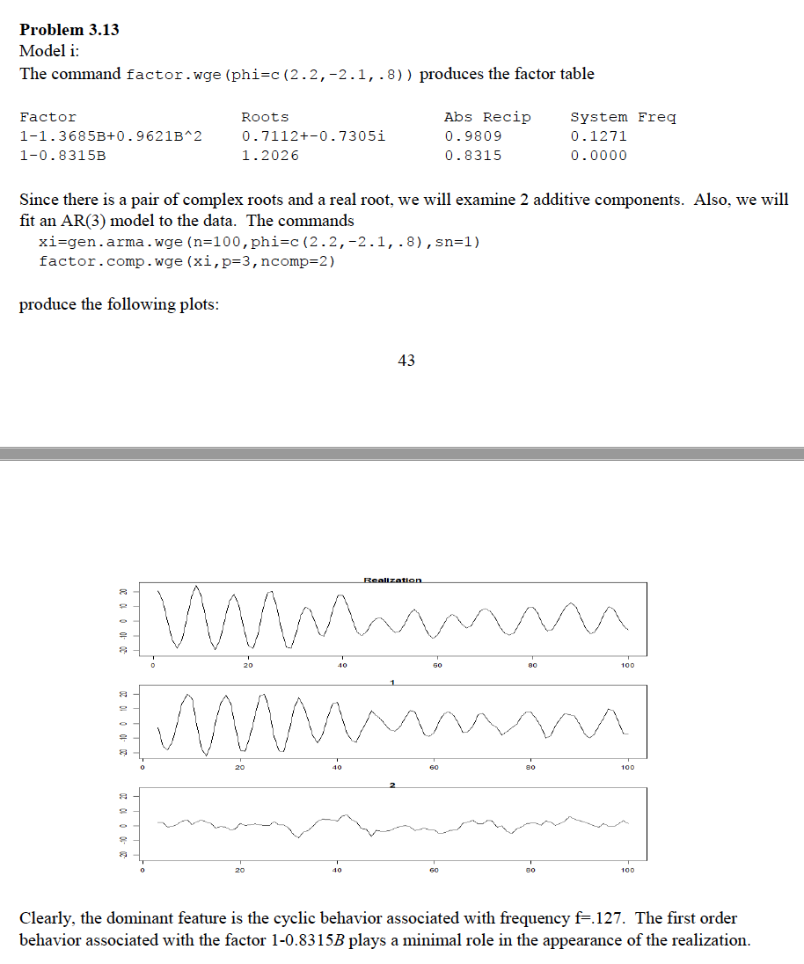



DS 6373: Time Series: Unit 6 HW Solutions

Below are the homework (HW) problems for this Unit. You do not need to submit the solutions rather double check your solutions to the solutions posted. Solutions will be posted to the Wall a few days after the release of the HW. This is intended to let the student think about the problem and attempt it without the temptation to first look at the solution. Please write any questions to the Wall or in an email to myself and/or bring them up during office hours or even in the next Live Session. Remember that the concepts covered below are fundamental to the course and are fair game for the midterm and final.

Have a blast!

Problems from Chapter 5 of the Textbook:

5.1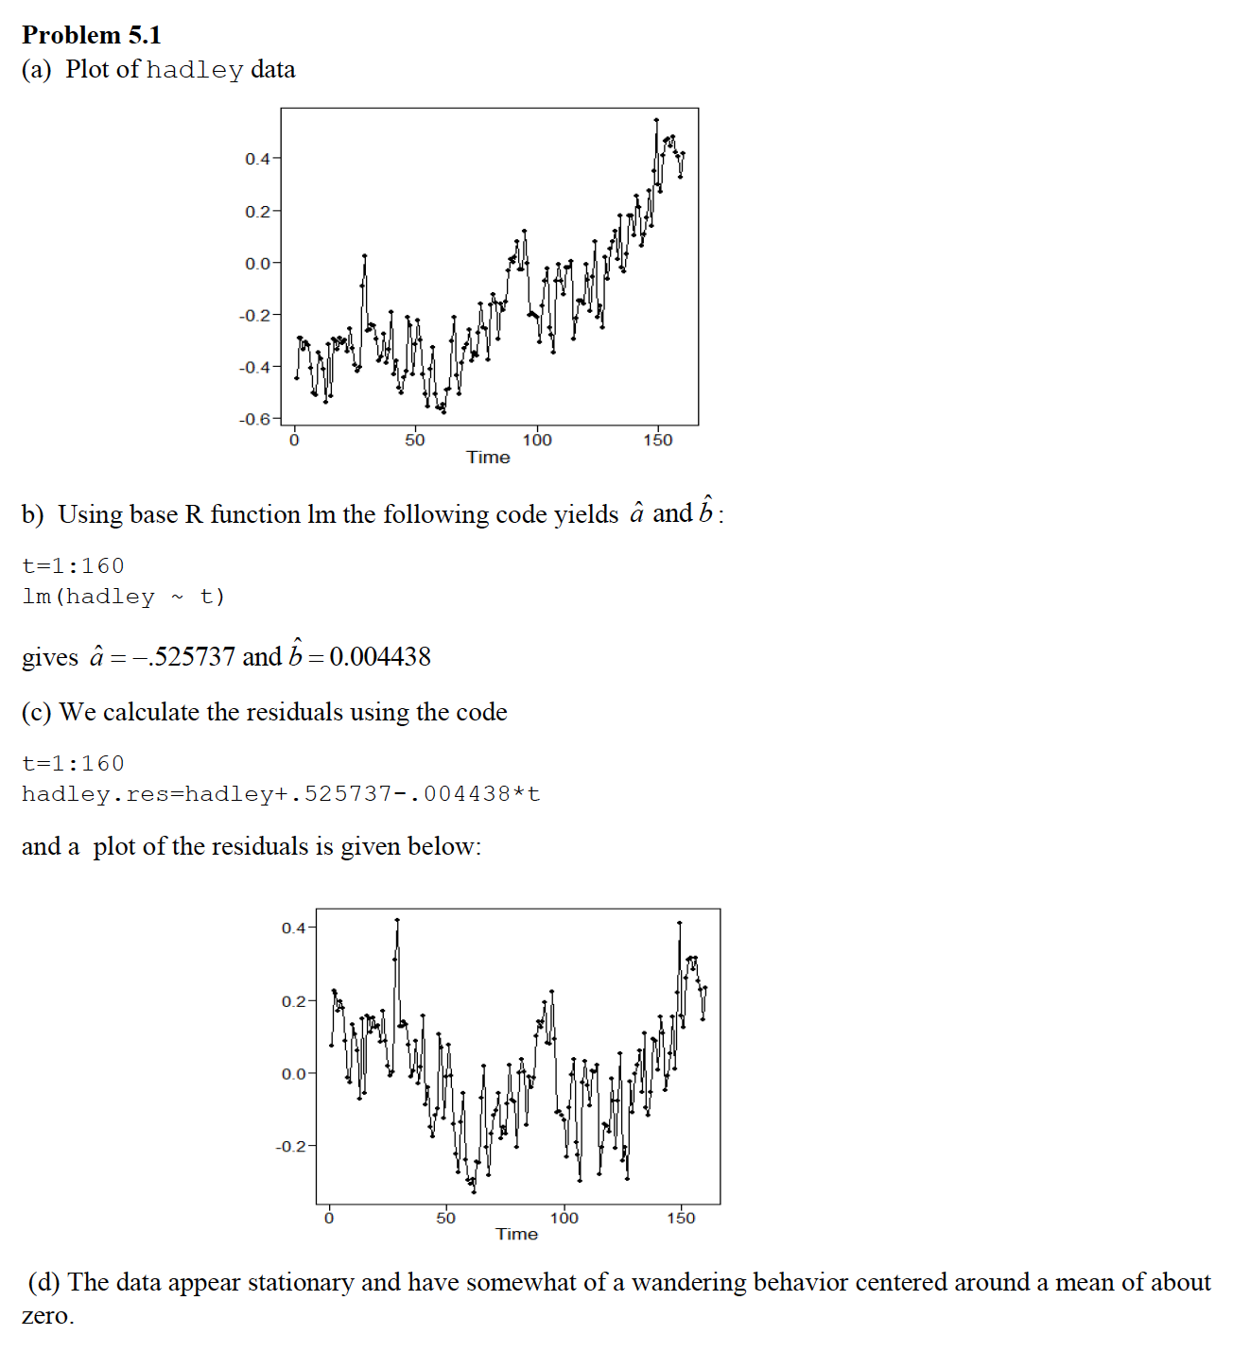

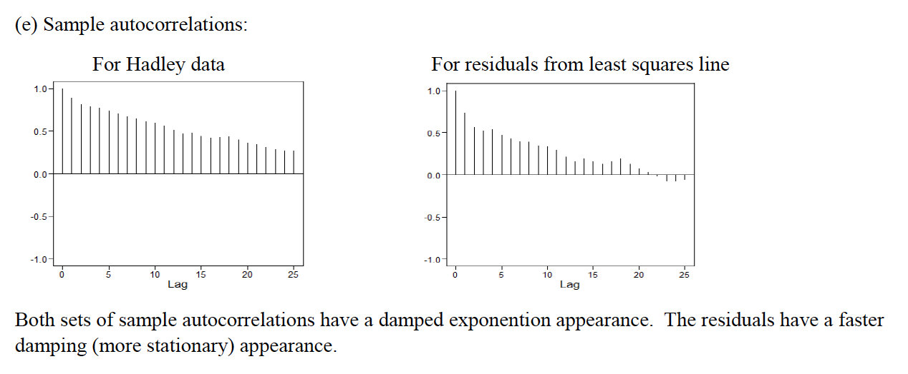

5.2

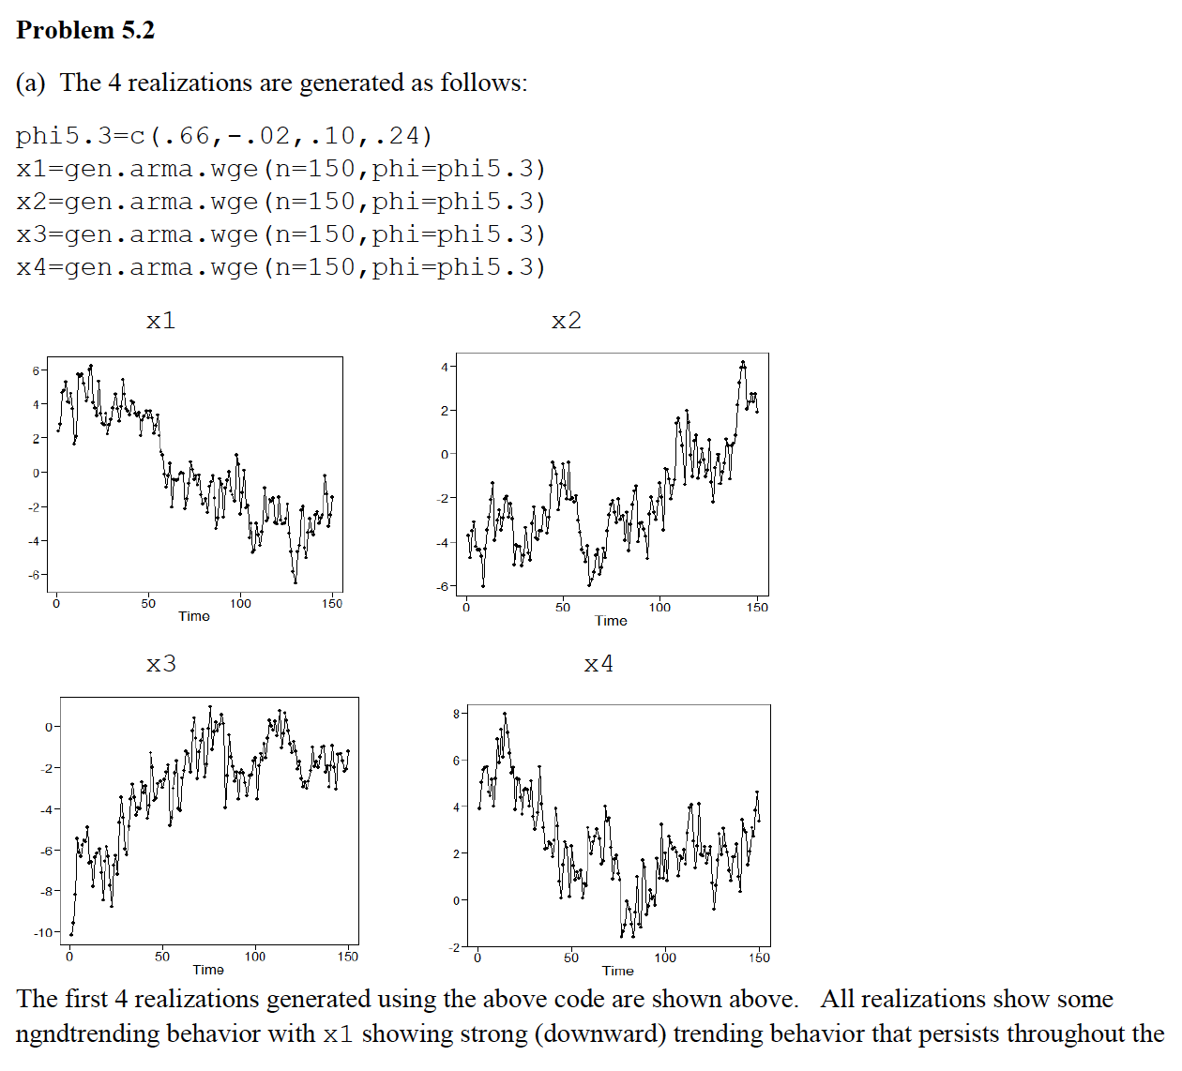

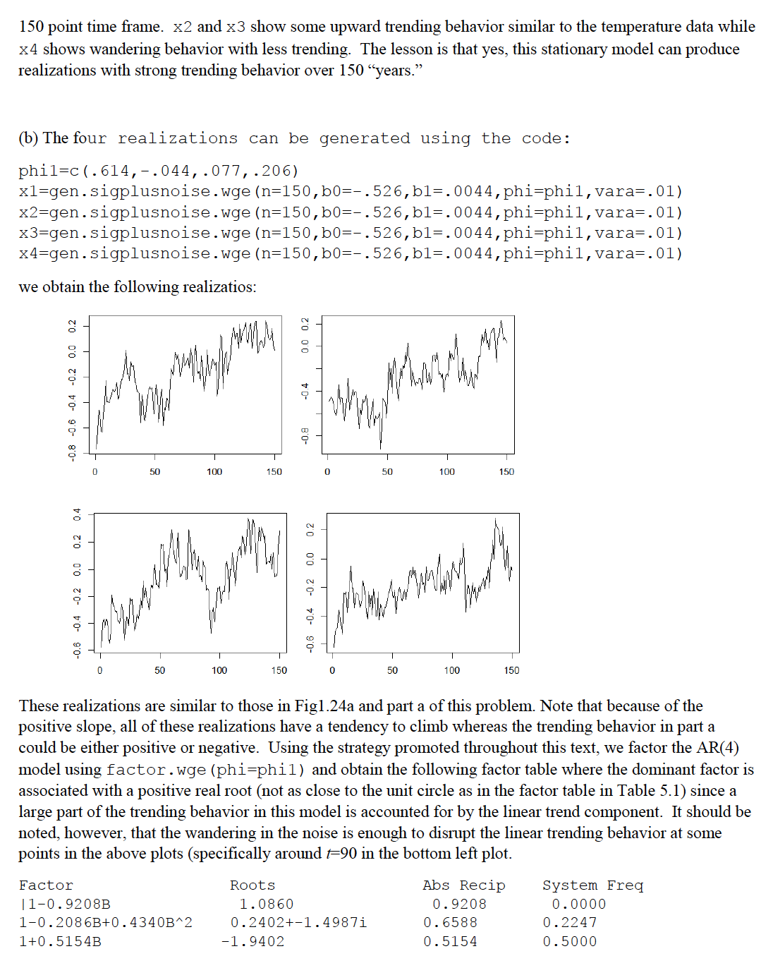

5.3 (a,b and d)

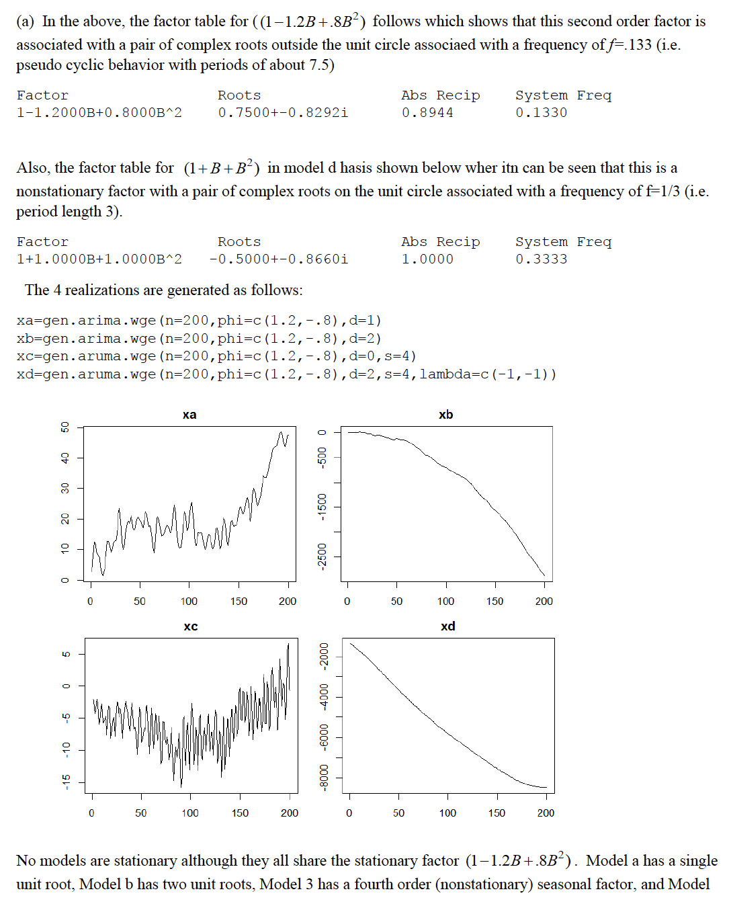

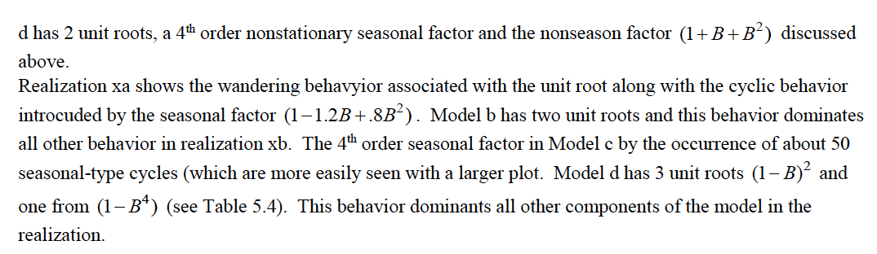

5.7

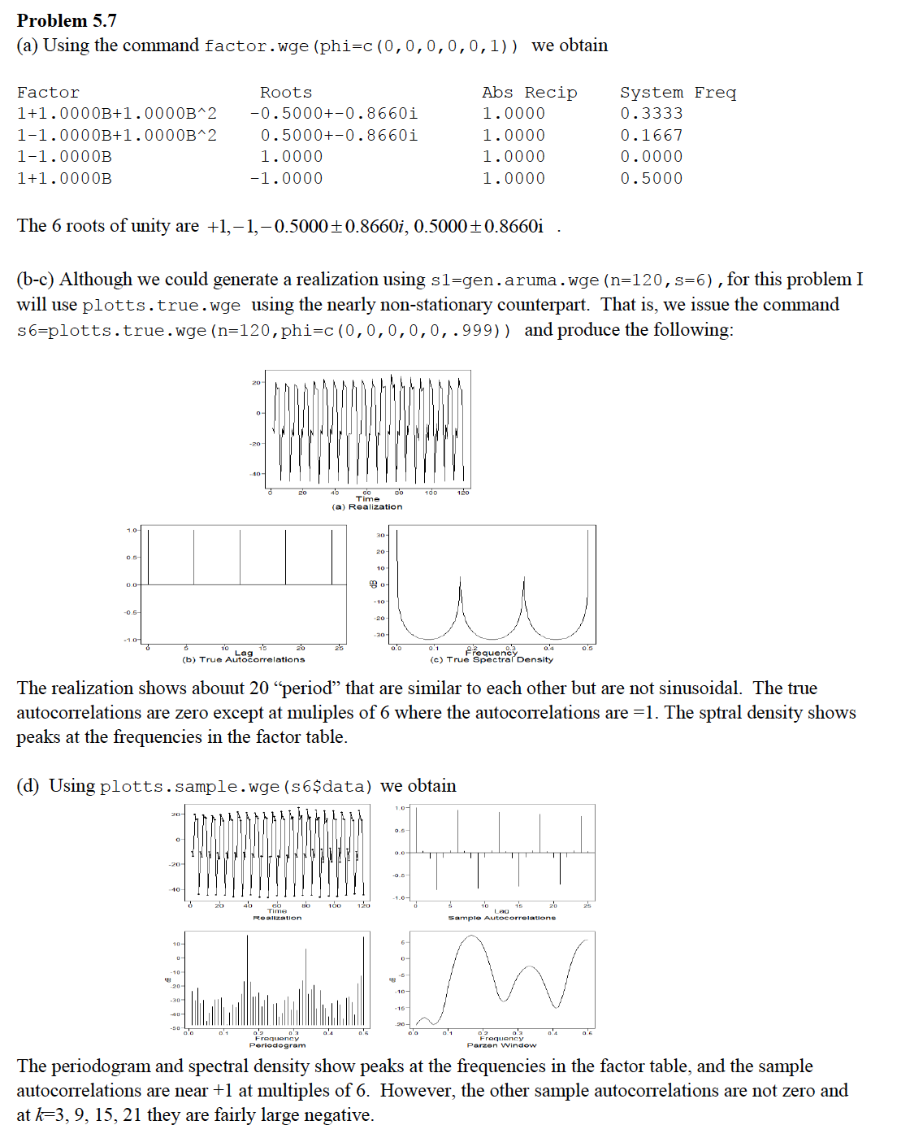

DS 6373: Time Series: Unit 7 HW Solutions

Below are the homework (HW) problems for this Unit. You do not need to submit the solutions rather double check your solutions to the solutions posted. Solutions will be posted to the Wall a few days after the release of the HW. This is intended to let the student think about the problem and attempt it without the temptation to first look at the solution. Please write any questions to the Wall or in an email to myself and/or bring them up during office hours or even in the next Live Session. Remember that the concepts covered below are fundamental to the course and are fair game for the midterm and final.

Have a blast!

Problems from Chapter 6 of the Textbook:

6.1

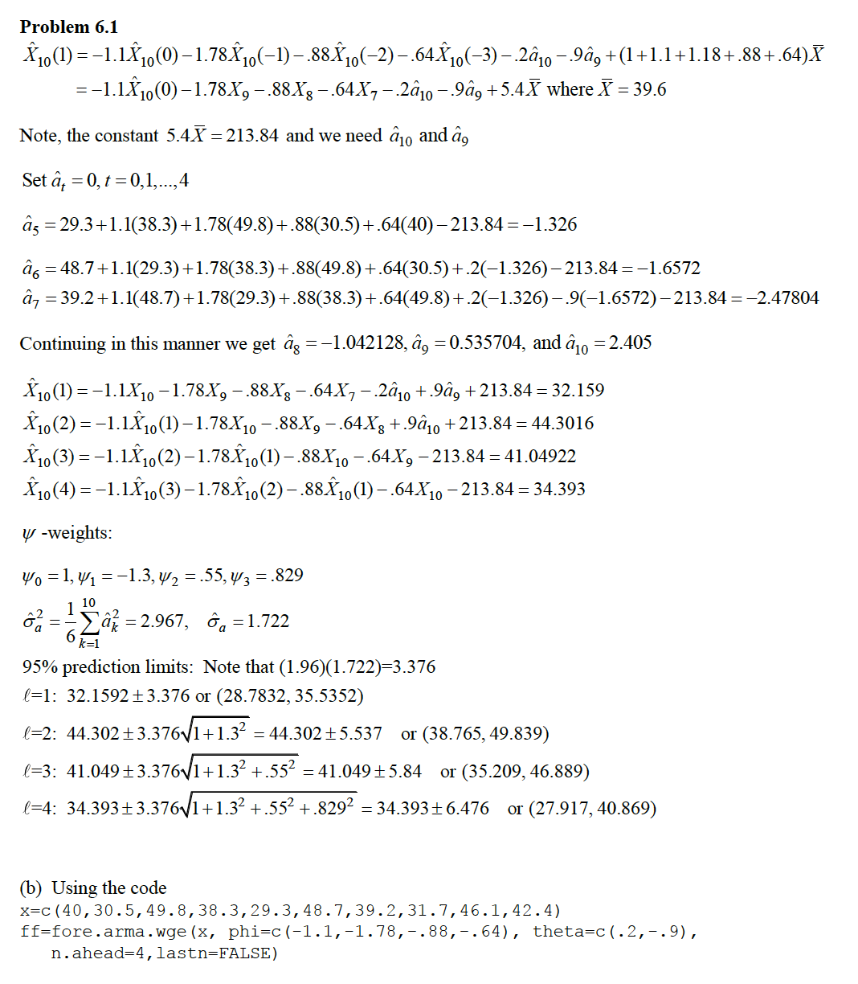

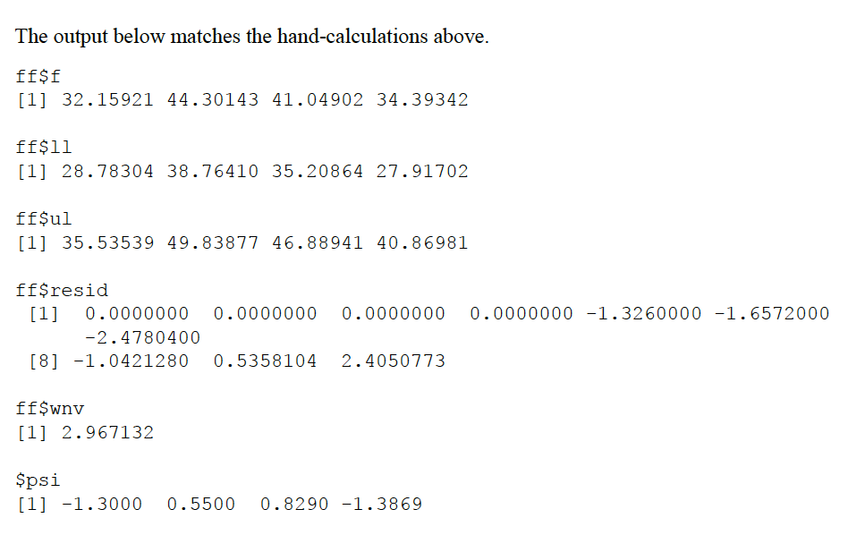

6.3 (For part c include the ASE)

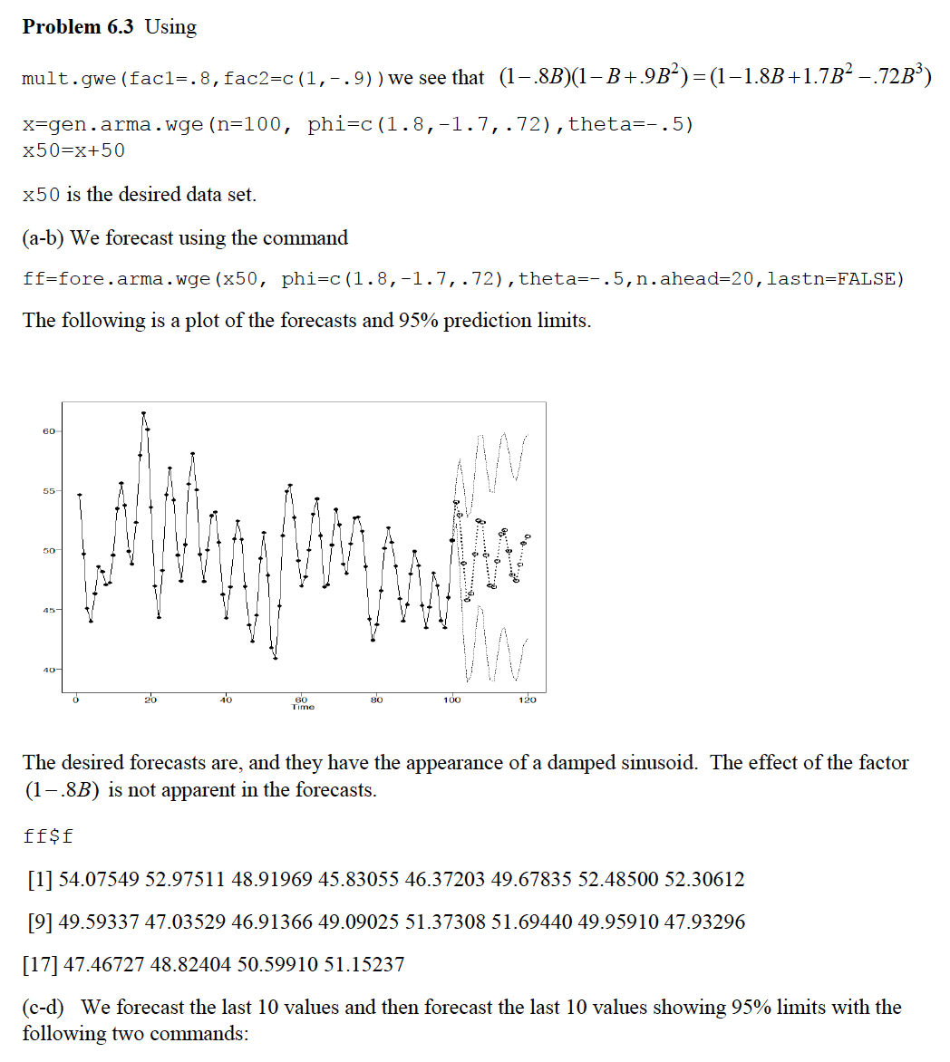

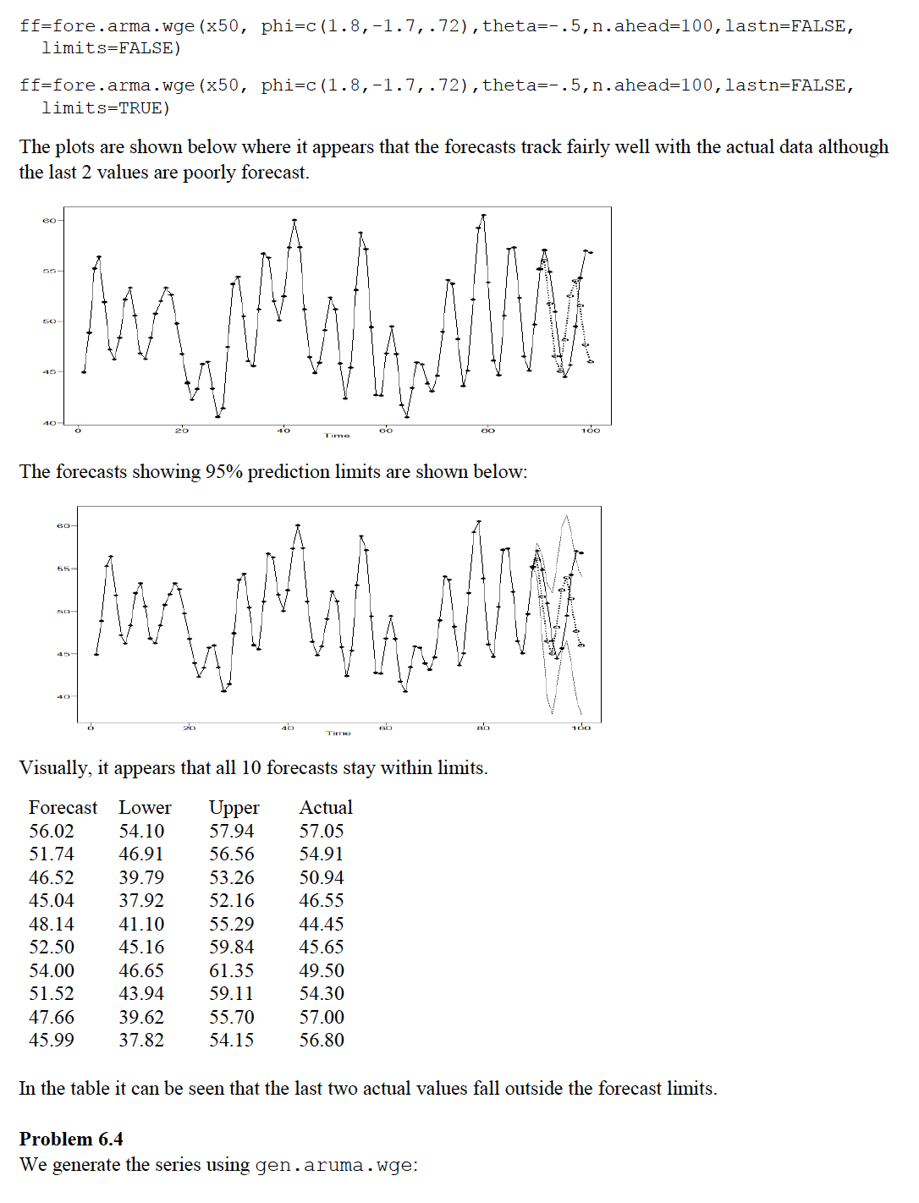

6.4

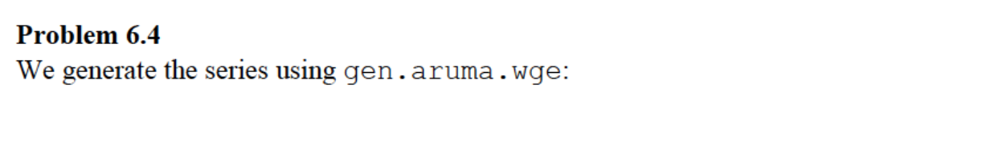

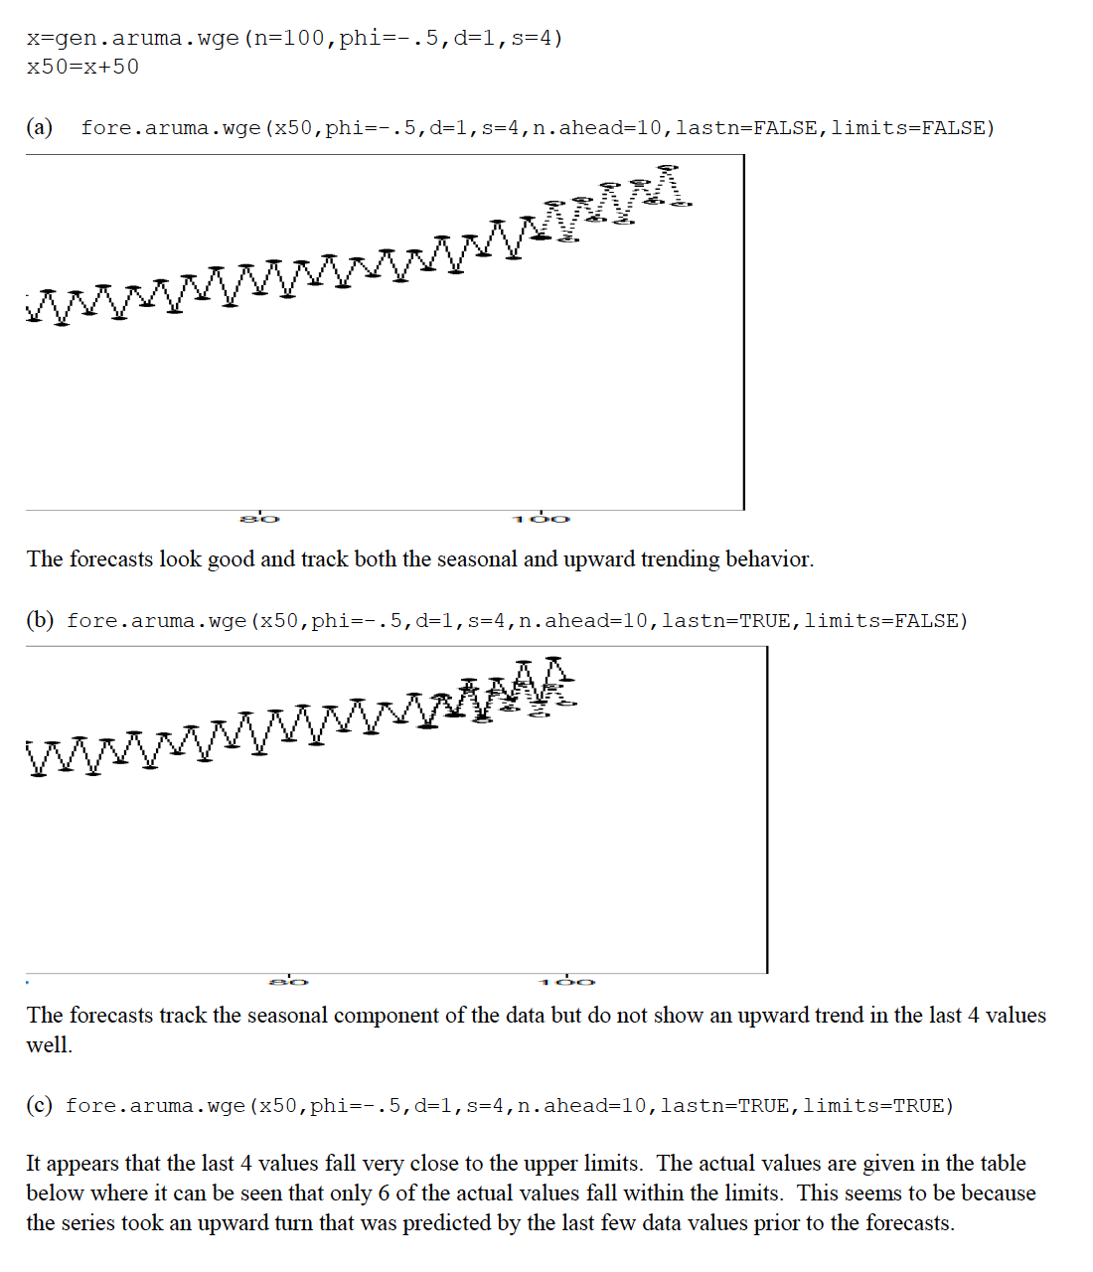

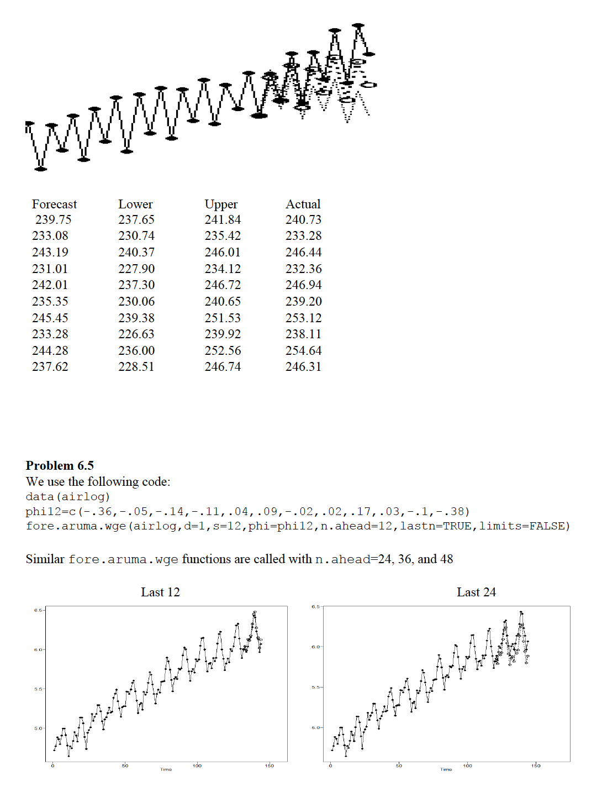

6.7

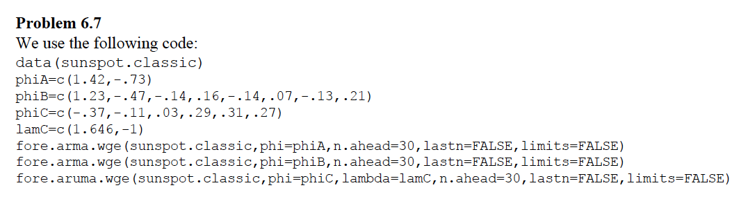

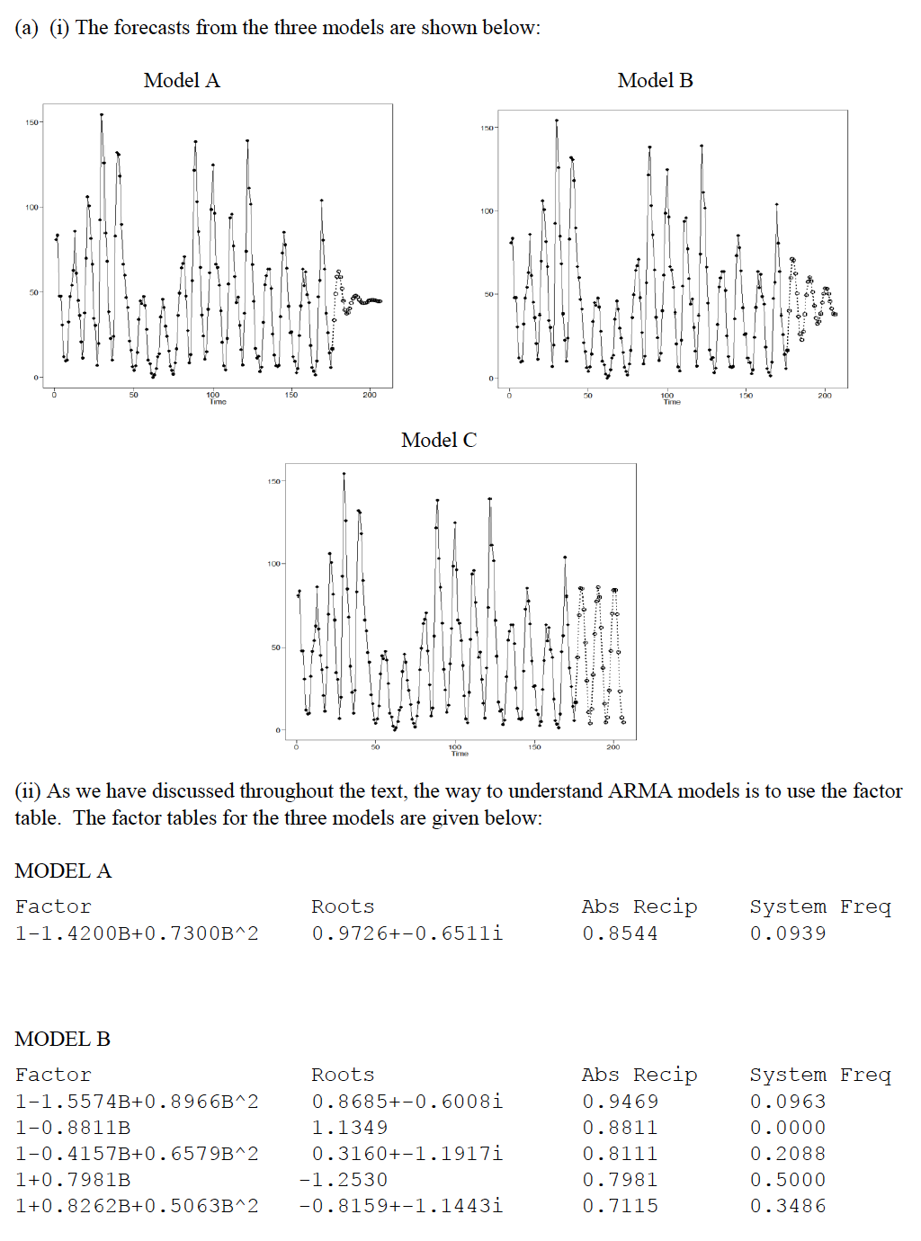

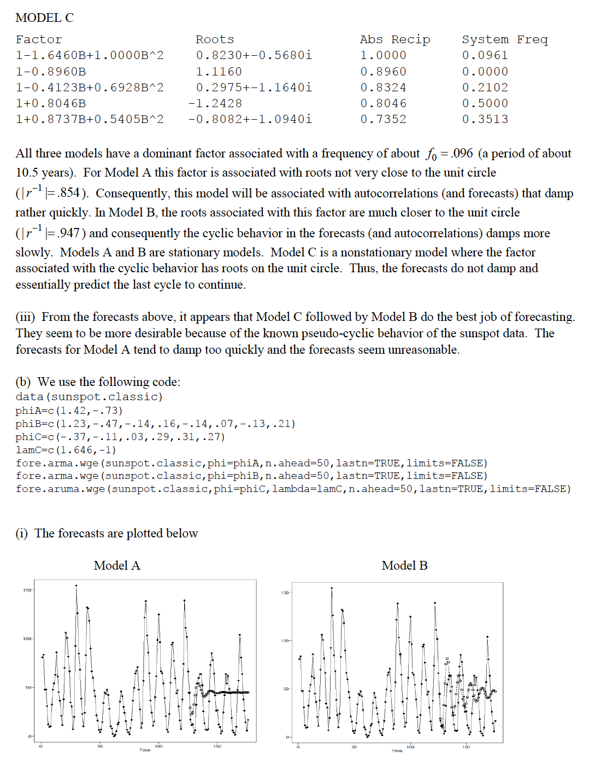

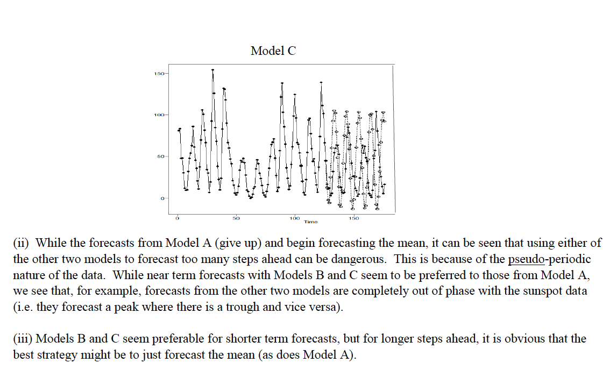

6.8

